
Cognizant Technology Solutions
2026
Detailed Technical Design Document

 | Prepared By | Reviewed by | Approved By
Name
Role
Signature
Date

Table of Contents
Introduction 4
1.1 Purpose 4
1.2 Background 4
1.3 Scope 5
1.4 Assumptions 6
1.5 Data Flow for MDM implementation 9
1.6 ETL Design and Data Transformation 9
ETL Mapping Diagram 13
1.7 Data Layers in the MDM Architecture 17
- MDM Landing tables 17
- Base Objects 19
- MDM Staging Tables 20
- MDM Lookup Tables 24
- MDM Lookup Staging Table 26
- MDM Lookup Staging Mapping 27
- MDM Staging Mapping 29
1.8 Project Architecture and Data Lifecycle 34
- Data Flow Design 34
Stage Process 34
Rejection handling in MDM Hub 35
Cleanse Functions and Mappings 35
Load process 35
Match Process 36
-  Match Columns 36
-  Match Rules 37
1.9 Trust Rules 39
-  Trust Logic and Decay 39
1.10 Batch Job Execution and Monitoring 46
1.11 Queries (Landing table insert statements) 55

Introduction

1.1 Purpose
The purpose of this project is to implement a robust Informatica MDM solution that consolidates fragmented traveler data into a single, reliable "Golden Copy."
Key Objectives:
- Data Consolidation: Integrate disparate data feeds from three primary sources (WEB, AGY, and PRT) into a centralized Master Hub.
- Identity Resolution: Utilize fuzzy and exact match logic to identify duplicate records across sources, ensuring that a single traveler is not represented multiple times.
- Data Quality Assurance: Apply standardized cleansing and validation rules to ensure the contactability and accuracy of "privileged" customer data.
- Strategic Marketing Enablement: Provide the aviation company with a clean, 360-degree view of travelers to drive targeted promotional offers and loyalty programs.

1.2 Background

In the competitive aviation industry, the ability to identify and reward "privileged" frequent travelers is a primary revenue driver. However, the company currently faces a "Siloed Data" challenge.
The Current State:
- Disparate Data Sources: Information is flowing in from a Direct Web Portal (WEB), external Travel Agencies (AGY), and third-party Partners (PRT).
- Data Inconsistency: Each source has its own format, varying levels of data quality, and unique identifiers (Source Keys). For example, "Jon Doe" in the Web portal might be "J. Doe" in the Agency file.
- Redundancy: Without a central hub, the company likely sends duplicate promotions to the same person or fails to recognize a high-value traveler because their history is split across systems.
The Solution:
We have been tasked with building an MDM Hub using Informatica MDM and PowerCenter. By implementing a structured data lifecycle Landing, Staging, Loading, and Match/Merge the project will resolve these inconsistencies.

1.3 Scope

This Technical Design Scope covers the implementation of the Aviation Customer Master Hub (MDM), including the design of the landing zone, the Master Data Hub schema, and the end-to-end ETL integration.

1.3.1 Implementation Details
The implementation focuses on creating a unified profile for Frequent Air Travelers. The Master Hub stores the "Golden Copy" of the passenger, linking their core identity with multiple communication and location attributes. The data model includes:
- Customer Master (Parent): First Name, Last Name, Date of Birth (DOB), Gender, and Passport Number.
- Address Details (Child): Address Line 1, Address Line 2, City, State, Zip Code, and Country.
- Contact Details (Child): Phone Number and Email Address
1.3.2 ETL Processes
Informatica PowerCenter is utilized as the primary ETL engine to acquire raw data from source files and publish it to the MDM Landing layer. The scope includes:
- Pre-MDM Processing: Extraction from flat files, data type conversion, and loading into LND tables.
1.3.3 Data Scrubbing and Standardization
To ensure high match accuracy, the following standardization logic was implemented within the ETL and MDM layers:
- Name & Geography: Standardization of First Name, Last Name, and City using Title Case logic.
- Identity: Formatting of Passport Numbers and validation of Date of Birth (DOB).
- Contact Information: Standardizing Email IDs to Lowercase and stripping non-numeric characters from Phone Numbers using Regular Expressions (Regex).
- Reference Data: Standardizing Gender and Country codes through the use of Lookup Base Objects (LKP_GENDER, LKP_COUNTRY).

1.3.4 Data Sources for MDM Hub
The MDM Hub is designed to integrate and resolve data from three distinct source systems provided via flat-file interfaces:
- WEB (Direct Online Portal): Considered the high-confidence source.
- AGY (Travel Agency): Secondary source for booking data.
- PRT (Partner Airlines): Third-party data with high volatility.
1.3.5 Downstream Data Publishing
The project concludes with the creation of a Publishing Layer. Once MDM has performed Match and Merge operations to create the Golden Record, an ETL process maps these records 1-to-1 from the Base Object to a target SQL table. This ensures the clean, de-duplicated data is available for the Aviation Company’s promotional campaigns.

1.4 Assumptions
The design and implementation of the Aviation Customer Master Hub are based on the following technical and operational assumptions:
- Source Reliability: All flat-file feeds (WEB, AGY, PRT) are available for batch processing with constant unique identifiers.
- Trust Priority: The WEB source is assumed to be the most accurate, warranting the highest trust score.
- Identity Uniqueness: A combination of Passport Number and Date of Birth is considered a definitive unique identifier for a traveler.
- Standardized Formats: Reference data (Gender/Country) is assumed to be pre-standardized to match the Hub's lookup codes.
- Infrastructure: A stable connection exists between Informatica PowerCenter and the MDM Hub for seamless data movement.
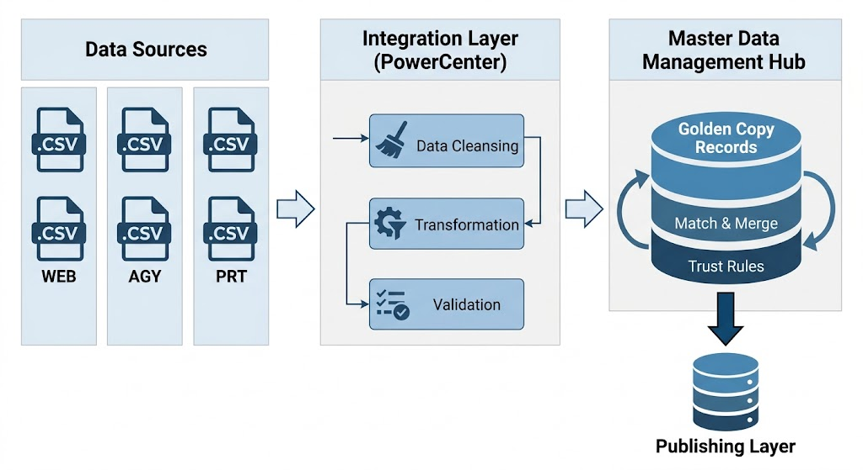

1.5 Data Flow for MDM implementation
The figure below represents the complete data flow diagram from the EDR Subscription Files (Upper Left) through landing areas, MDM and Final Stage.

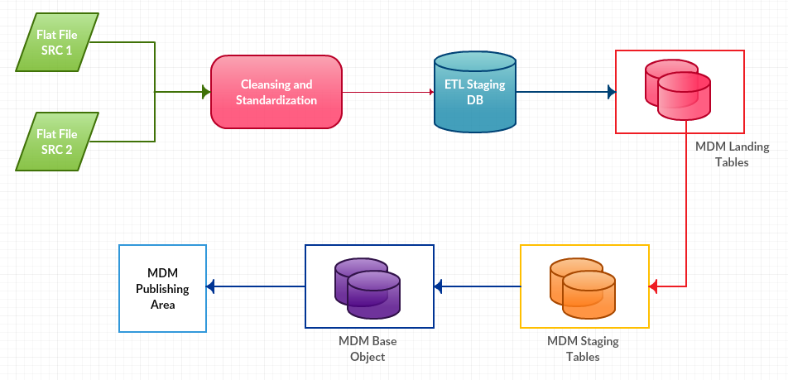
Fig: Data Flow diagram MDM implementation

1.6 ETL Design and Data Transformation

The ETL (Extract, Transform, Load) layer serves as the primary gateway for ingesting raw traveler data from WEB, AGY, and PRT flat files into the MDM ecosystem. Using Informatica PowerCenter, source definitions were created to mirror the incoming file structures, while target definitions were mapped to the LND_CUSTOMER, LND_ADDRESS, and LND_CONTACT tables.

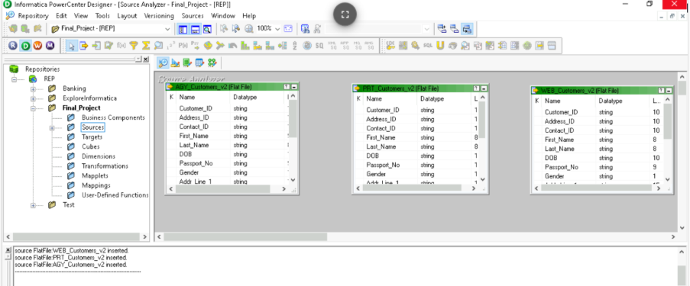

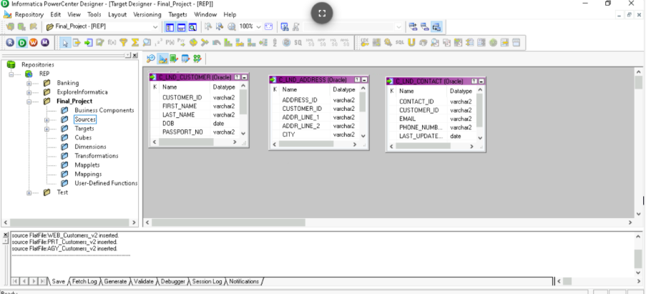

- ETL column mapping
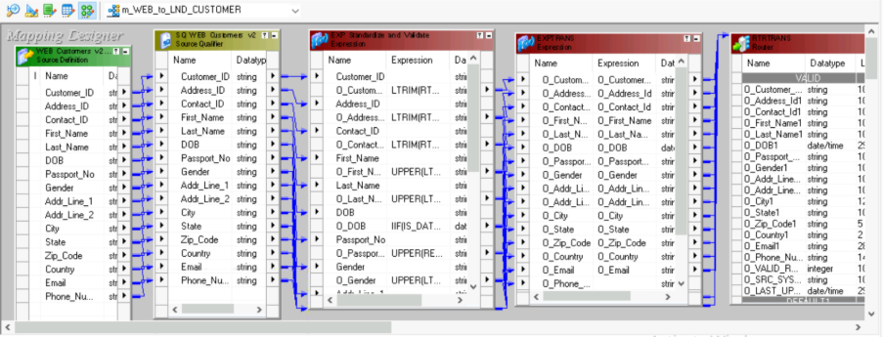
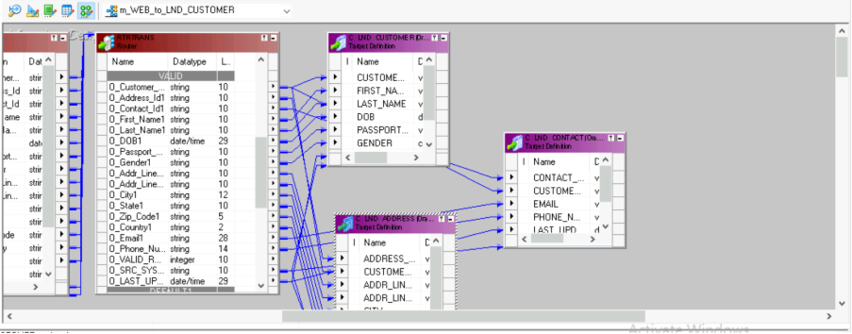

- ETL Transformation

Expression Transformation
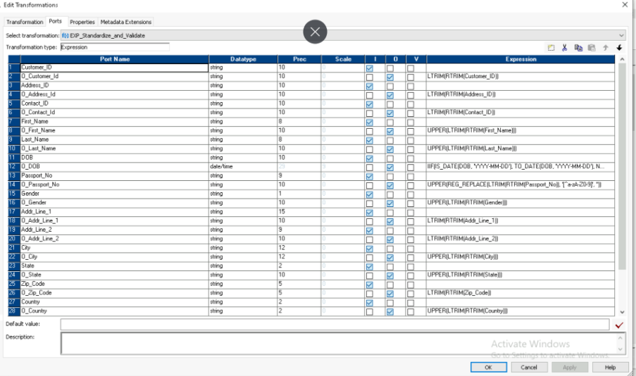

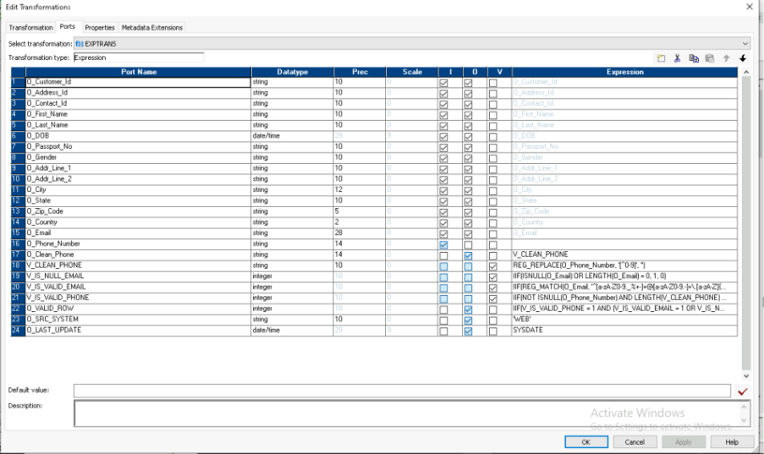

Router Transform
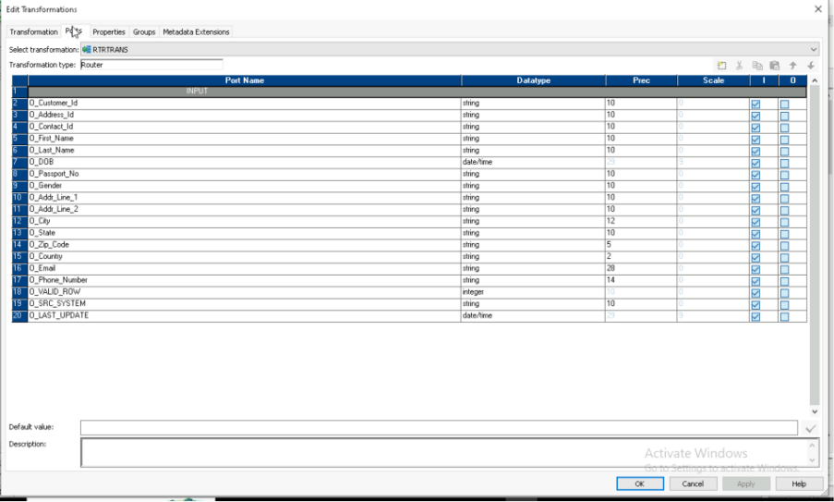
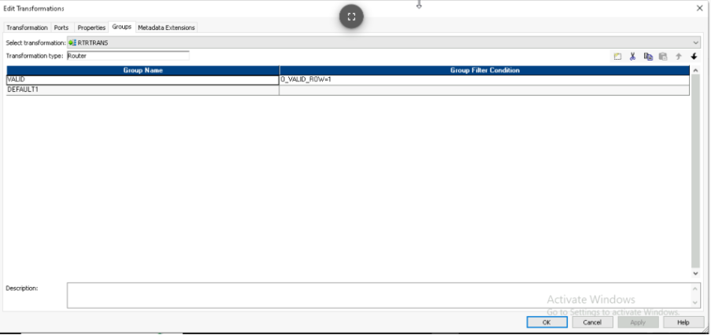

ETL Mapping Diagram

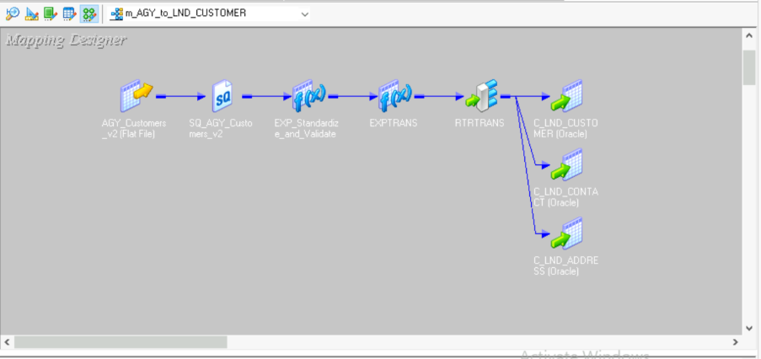

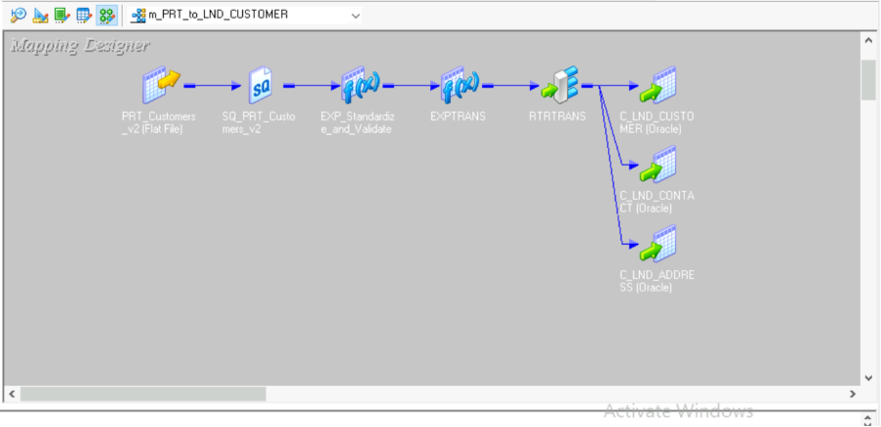

- ETL WORKFLOW DESIGNER AND MONITOR

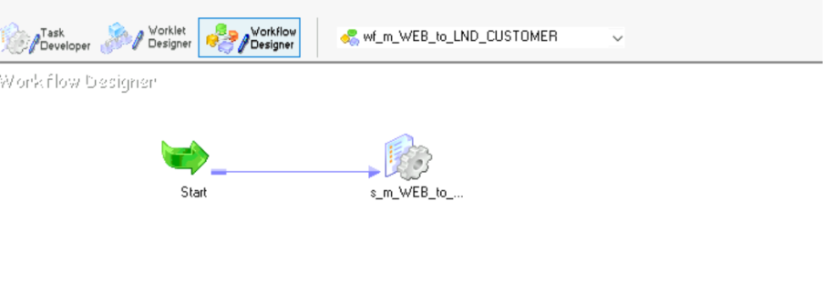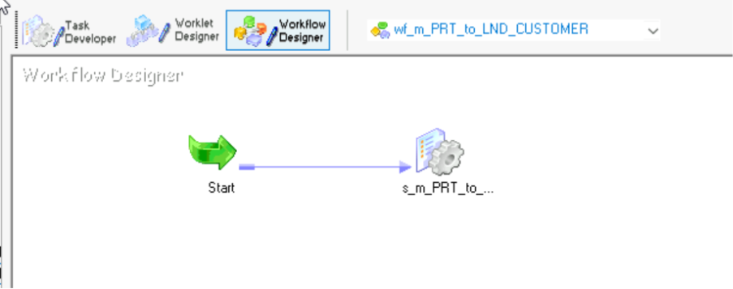

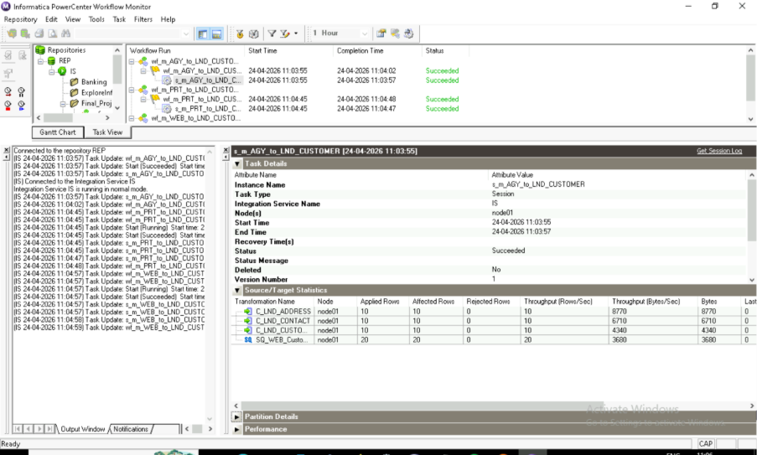
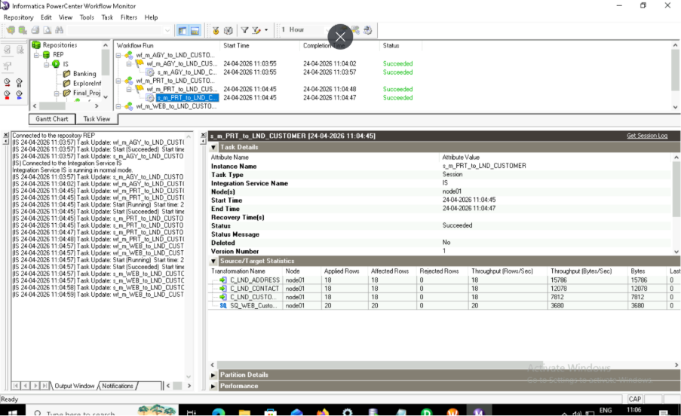

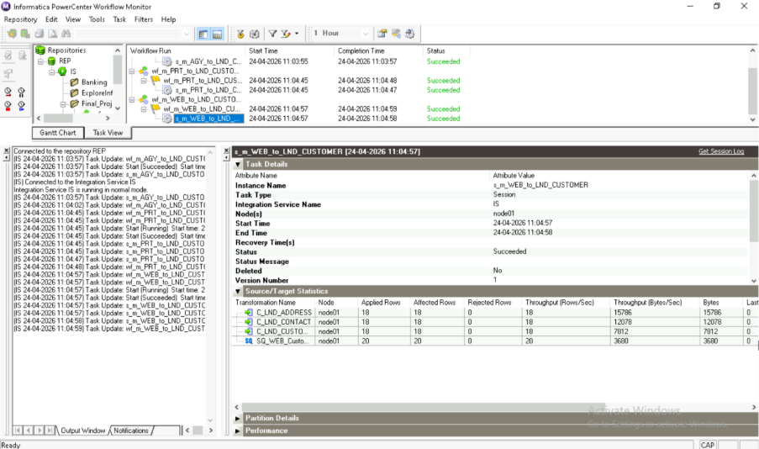

1.7 Data Layers in the MDM Architecture
The architecture includes a number of database and file layers that deliver and/or store data. A brief description of each layer is defined below.
The files are:

MDM Landing tables
MDM landing table are used to store data from ETL in form of Oracle tables. Tables that will be used as landing tables are as follow:

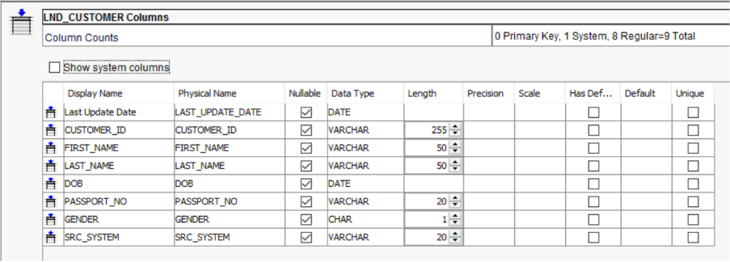
Landing Table Name: C_LND_CUSTOMER

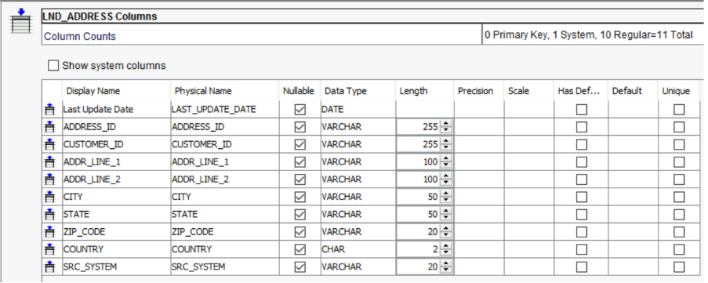
Landing Table Name: C_LND_ADDRESS

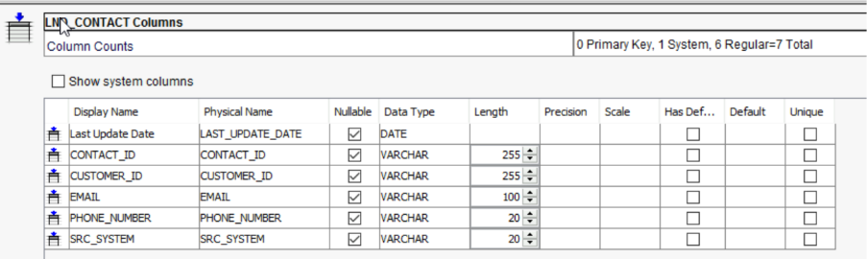
Landing Table Name: C_LND_CONTACT

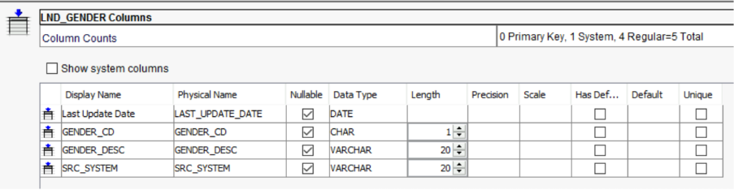
Landing Table Name: C_LND_GENDER

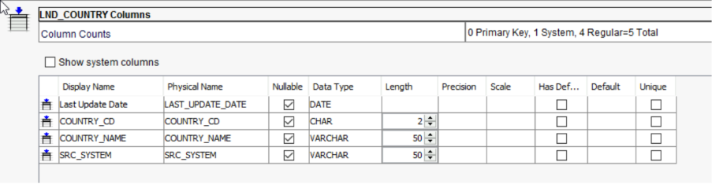
Landing Table Name: C_LND_COUNTRY

The following Landing tables serve as the entry point for raw batch data from WEB, AGY, and PRT source systems. These tables are designed to mirror the source file structures before any MDM-specific processing occurs.
- LND_CUSTOMER:
  - This table stores core traveler identity details.
  - Key Columns: CUSTOMER_ID (Source Key), FIRST_NAME, LAST_NAME, DOB, and PASSPORT_NO.
  - It includes a GENDER column that is subsequently validated against the LKP_GENDER lookup table during the stage process.
- LND_ADDRESS:
  - Utilized to capture geographical details for the travelers.
  - Attributes: Includes ADDR_LINE_1, ADDR_LINE_2, CITY, STATE, and ZIP_CODE.
  - The COUNTRY code is ingested here and later standardized against the LKP_COUNTRY reference table.
  - Contains CUSTOMER_ID as a foreign key to maintain a relationship with the parent record.
- LND_CONTACT:
  - Captures multi-channel communication details for frequent travelers.
  - Fields: Includes EMAIL and PHONE_NUMBER.
  - Contains CUSTOMER_ID as a foreign key used for internal resolution to the parent traveler profile during the Load job.
- LND_GENDER & LND_COUNTRY (Reference Landing):
  - These tables act as the landing zone for master reference data.
  - They consist of code-description pairs (e.g., GENDER_CD and GENDER_DESC) which are loaded into the MDM Hub's Lookup Base Objects to drive standardization.

Base Objects

MDM Base Objects serve as the core repository for the Aviation Master Data. Each Base Object (BO) is designed to store the "Best Version of Truth" (BVT) for traveler entities. While multiple source systems (WEB, AGY, PRT) may provide conflicting data for the same traveler, the consolidation process merges these into a single master record based on established Trust and Validation rules.

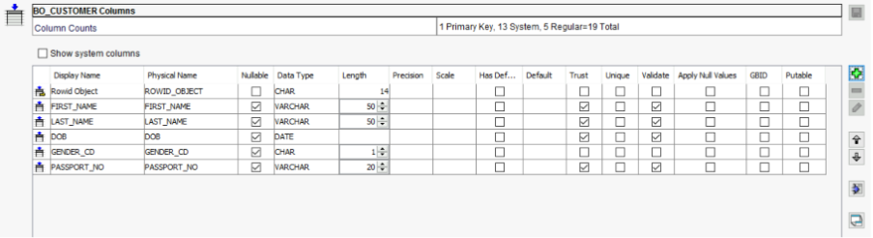

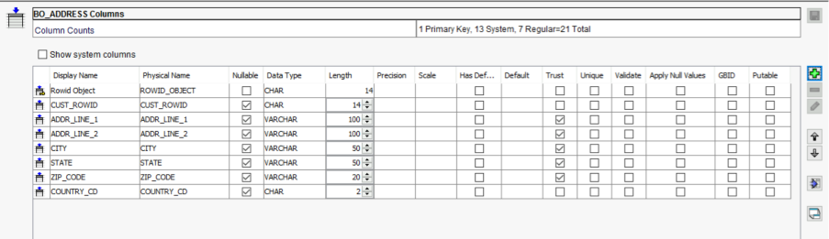

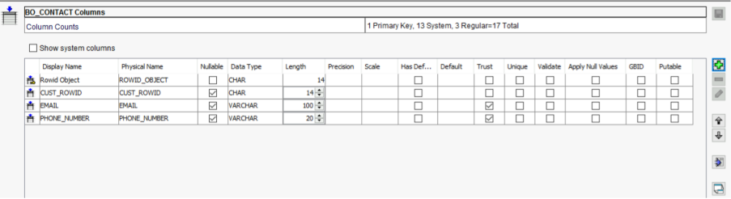

A single Base Object has several internal/system tables to collect rejected data, keep historical data, control the loads, keep cross-reference data, and so on.After the load of the Base Object, a tokenize process starts. This process generates match tokens that will be used subsequently by the match process to identify candidate Base Object records for matching

MDM Staging Tables
Staging tables are derived from a combination of the base object tables and landing tables. The columns within the staging tables will mimic that of the base object tables. However, the data to populate the staging tables will come from the landing tables.
It is supposed to exist one staging table for each source system that has information to load in the Base Object.

MDM STAGING TABLES
Customer Staging (Parent)

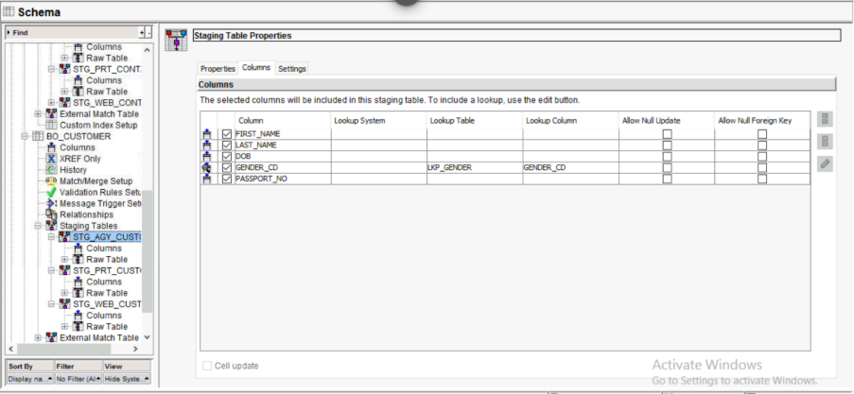
STG_AGY_CUSTOMER

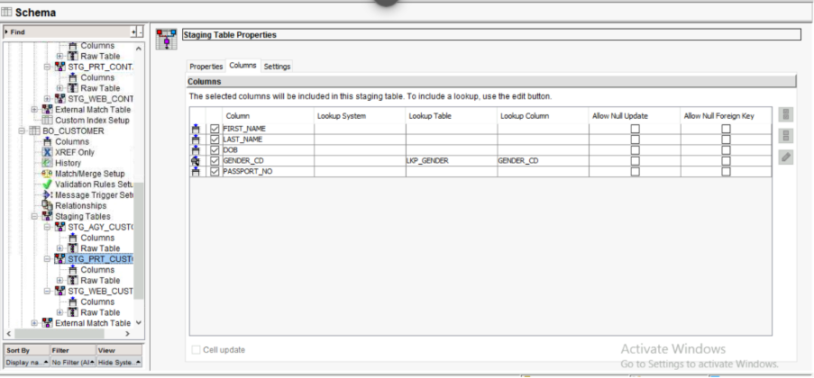
STG_PRT_CUSTOMER

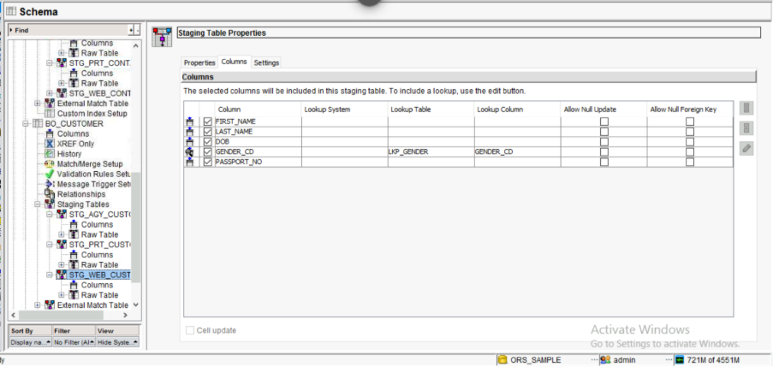
STG_WEB_CUSTOMER

Address Staging (Child)
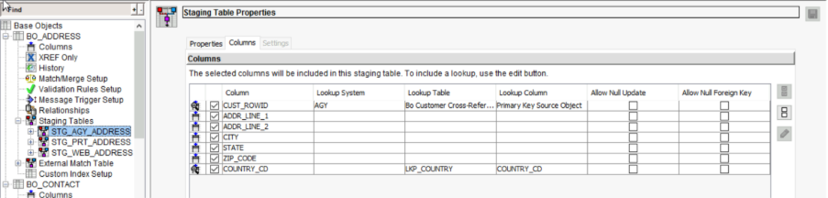
STG_AGY_ADDRESS

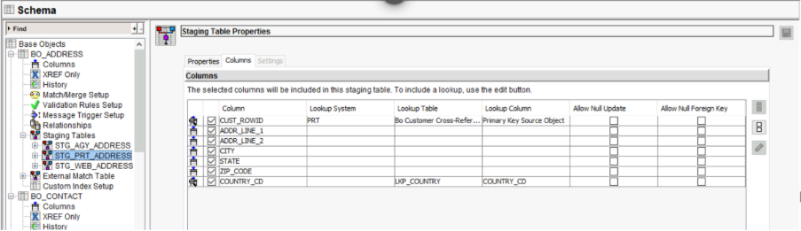
STG_PRT_ADDRESS

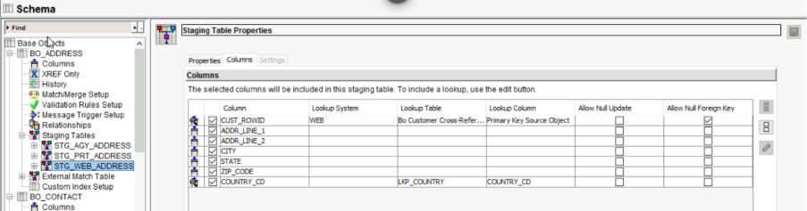
STG_WEB_ADDRESS

Contact Staging (Child)

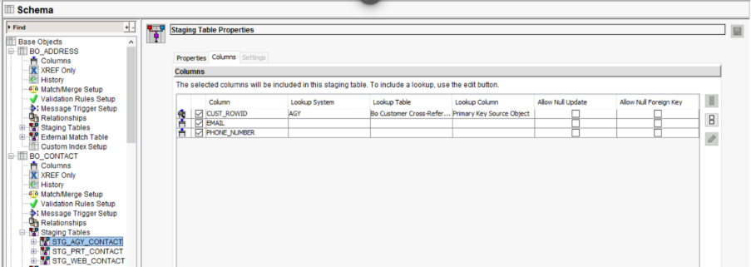
STG_AGY_CONTACT

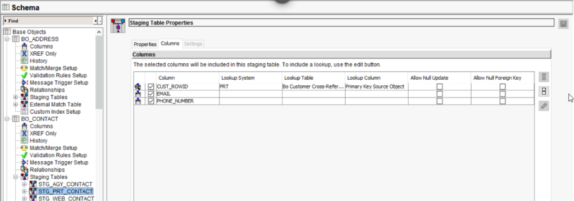
STG_PRT_CONTACT

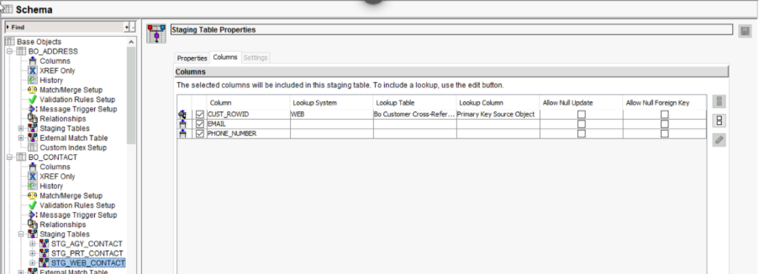
STG_WEB_CONTACT

STG_WEB_CUSTOMER: Contains traveler identity details sourced from the Direct Web portal. Includes FIRST_NAME, LAST_NAME, and DOB, with gender codes validated against LKP_GENDER.
STG_AGY_CUSTOMER: Stores traveler records from Travel Agencies. It maintains the same structure as the WEB staging table but is assigned a lower trust priority.
STG_PRT_CUSTOMER: Handles third-party Partner Airline feeds. This table often triggers delta detection as partner feeds frequently provide duplicate traveler profiles.
STG_WEB_ADDRESS / STG_AGY_ADDRESS / STG_PRT_ADDRESS: These tables capture ADDR_LINE_1, CITY, and STATE. Each record contains CUST_PKEY as a foreign key, which MDM resolves against the parent BO_CUSTOMER to maintain passenger-address links. COUNTRY_CD is validated against the LKP_COUNTRY table to ensure geographical standardization.
STG_WEB_CONTACT / STG_AGY_CONTACT / STG_PRT_CONTACT: Designed to retrieve communication details including EMAIL and PHONE_NUMBER. Cleanse Integration: These tables store the results of PowerCenter cleansing logic, such as email strings converted to lowercase to ensure consistency during match runs.

MDM Lookup Tables
A Lookup Table is a specialized Base Object in Informatica MDM that stores a master list of permitted values and their descriptions for a specific attribute. Its primary purpose is to act as a "dictionary" that the system uses to standardize incoming raw data into a uniform format.

C_LKP_GENDER

Attribute Name | Data Type | Key Type | Description / Purpose
ROWID_OBJECT | CHAR(14) | Primary  Key | System-generated unique identifier
GENDER_CD | CHAR(1) | Natural Key | The code ('M', 'F', 'U').
GENDER_DESC | VARCHAR(20) |  | Full description ('Male', 'Female', 'Unknown').

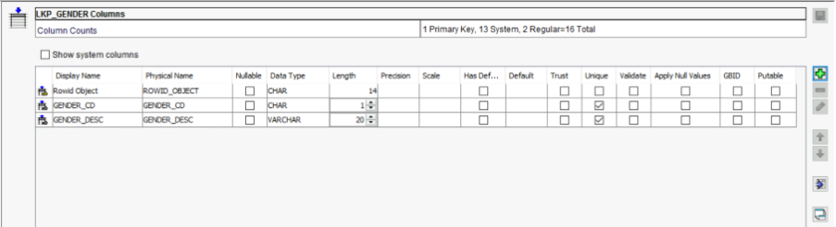

C_LKP_COUNTRY

Attribute Name | Data Type | Key Type | Description / Purpose
ROWID_OBJECT | CHAR(14) | Primary  Key | System-generated unique identifier
COUNTRY_CD | CHAR(2) | Natural Key | ISO Country Code (e.g., 'US', 'IN').
COUNTRY_NAME | VARCHAR(50) |  | Full name of the country.

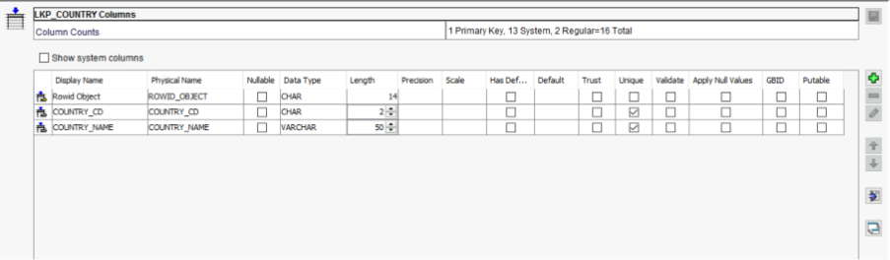

MDM Lookup Staging Table

C_STG_REF_COUNTRY (Filter applied: SRC_SYSTEM = 'SYS_REF')

Attribute Name | Data Type | Mapped From | Description / Purpose
KEY_SRC_OBJECT | VARCHAR(255) | COUNTRY_CD | The Code acts as the unique source  key (e.g., 'US', 'IN').
COUNTRY_CD | CHAR(2) | COUNTRY_CD | Passed throug.
COUNTRY_NAME | VARCHAR(50) | COUNTRY_NAME | Passed through

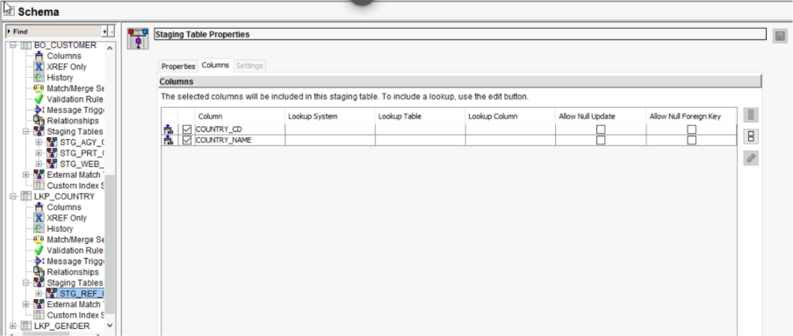

C_STG_REF_GENDER (Filter applied: SRC_SYSTEM = 'SYS_REF')

Attribute Name | Data Type | Key Type | Description / Purpose
PKEY_SRC_OBJECT | CHAR(14) | GENDER_CD | The Code acts as the unique source key(e.g., 'M', 'F').
GENDER_CD | CHAR(1) | GENDER_CD | Passed  through.
GENDER_DESC | VARCHAR(20) | GENDER_DESC | Passed  through

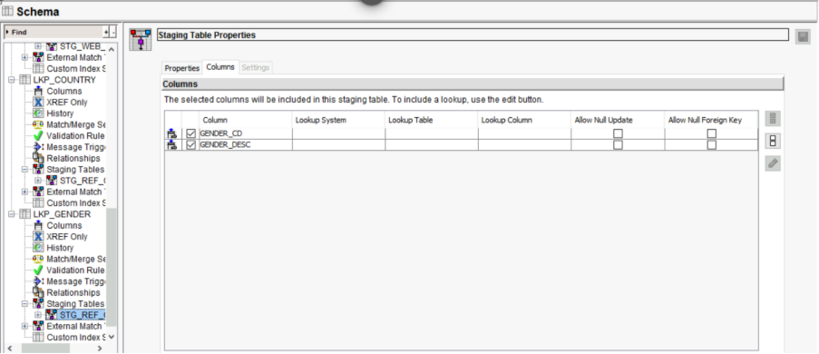

MDM Lookup Staging Mapping
The logic to load data into the Staging Tables, coming from the Landing Tables, is designed into the Mappings. For each mapping, one (and only) Landing Table is read and the rules to load data into the Staging table are applied. We have one Staging Table for each Source System, for each Lookup.

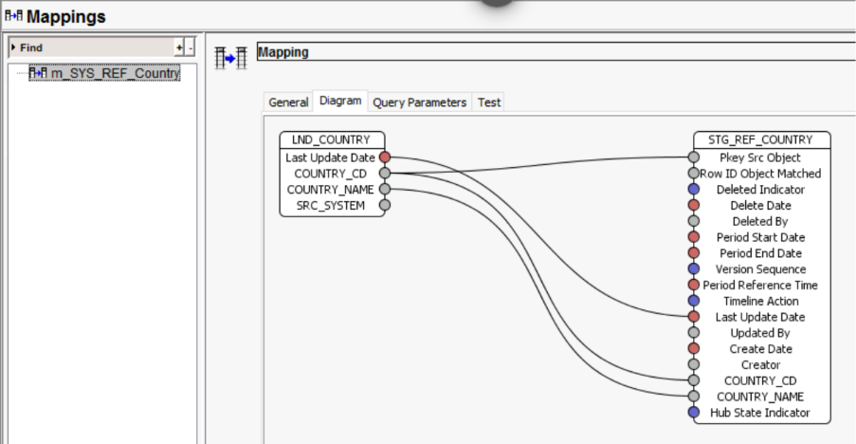
m_LND_to_STG_REF_COUNTRY:
- Source: LND_COUNTRY
- Target: STG_REF_COUNTRY
- Purpose: Maps ISO country codes and full names to the C_LKP_COUNTRY Base Object to ensure geographical consistency.

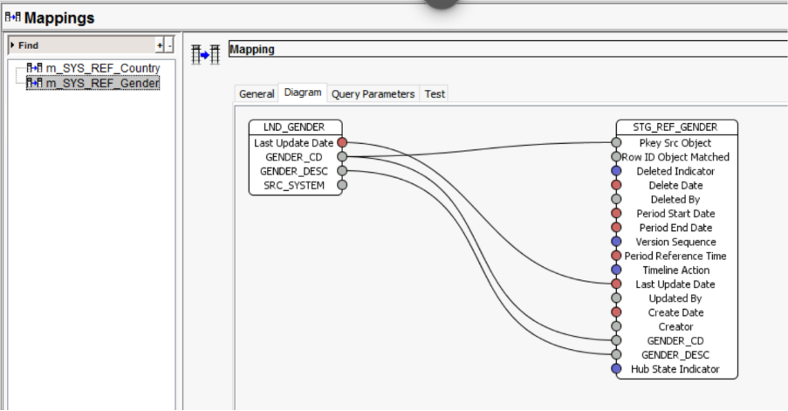
m_LND_to_STG_REF_GENDER:
- Source: LND_GENDER
- Target: STG_REF_GENDER
- Purpose: Standardizes raw gender codes and descriptions before they are loaded into the C_LKP_GENDER Base Object

MDM Staging Mapping
The logic to load data into the Staging Tables, coming from the Landing Tables, is designed into the Mappings. For each mapping, one (and only) Landing Table is read and the rules to load data into the Staging table are applied. We have one Staging Table for each Source System, for each Base Object.

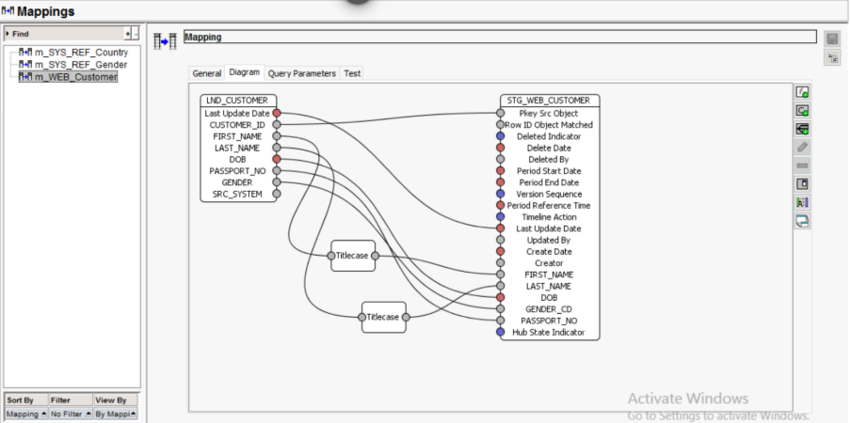
Mapping Name: m_LND_to_STG_WEB_CUSTOMER

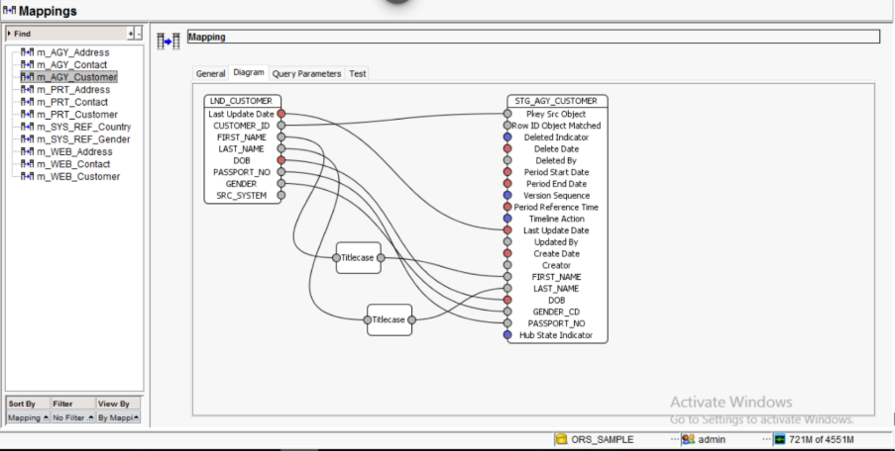
Mapping Name: m_LND_to_STG_AGY_CUSTOMER

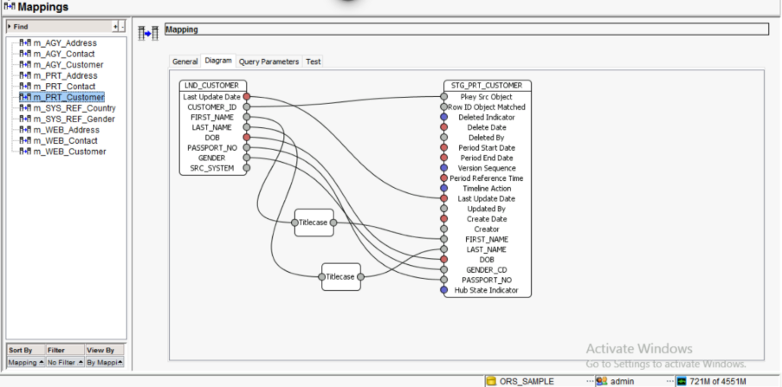
Mapping Name: m_LND_to_STG_PRT_CUSTOMER

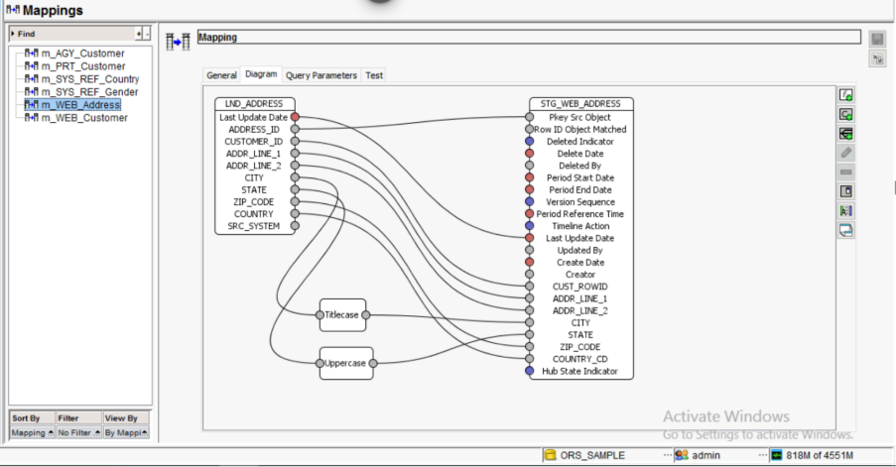

Mapping Name: m_LND_to_STG_WEB_ADDRESS
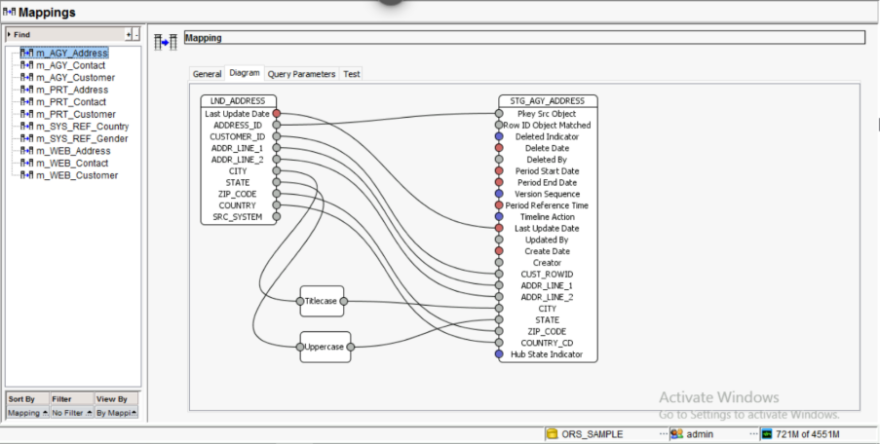
Mapping Name: m_LND_to_STG_AGY_ADDRESS

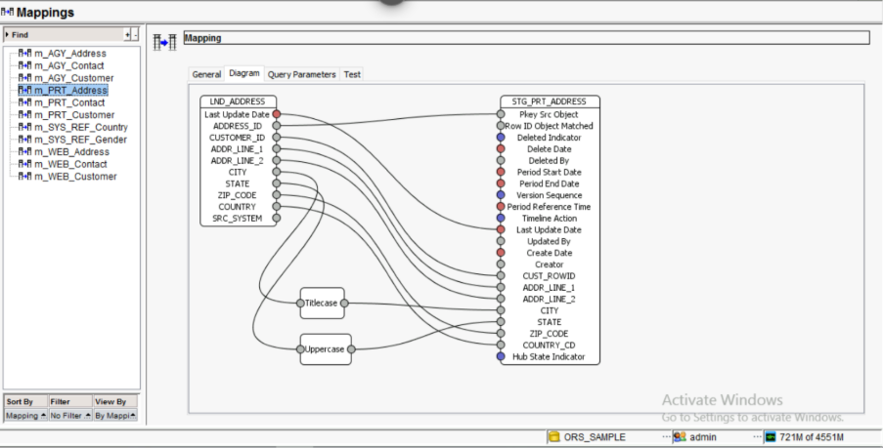
Mapping Name: m_LND_to_STG_PRT_ADDRESS

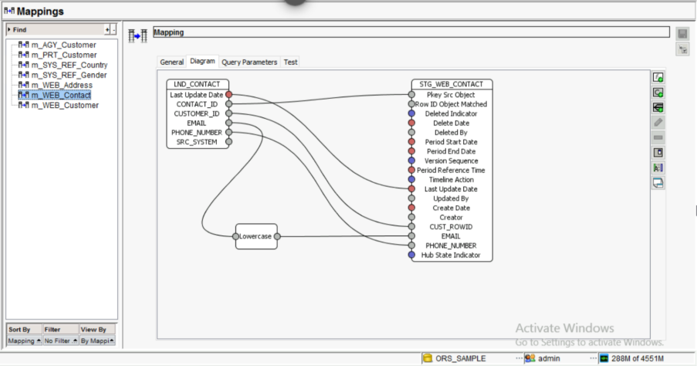
Mapping Name: m_LND_to_STG_WEB_CONTACT

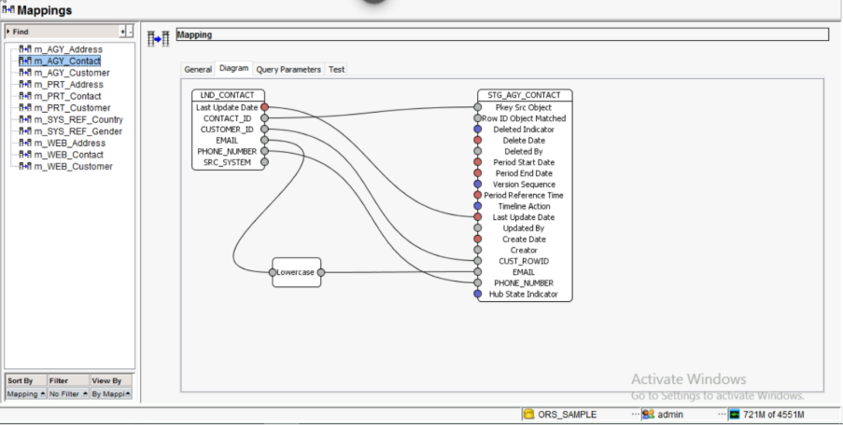
Mapping Name: m_LND_to_STG_AGY_CONTACT

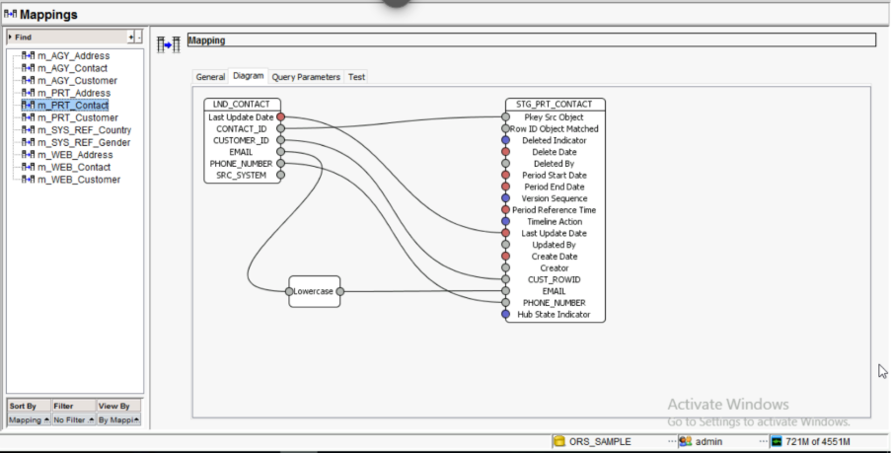

Mapping Name: m_LND_to_STG_PRT_CONTACT

- Mapping Query Parameters

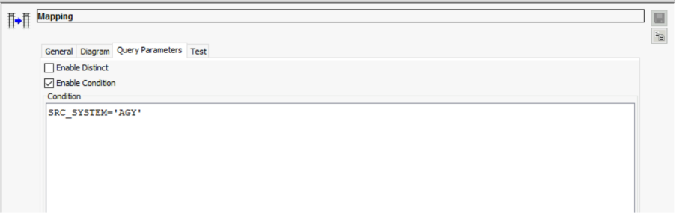

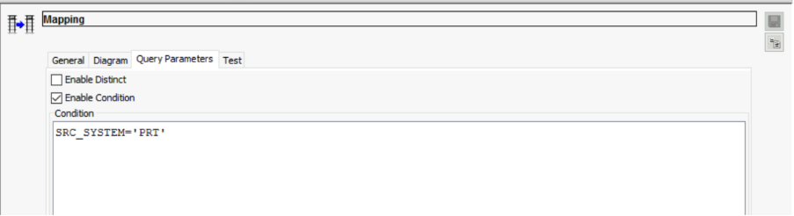

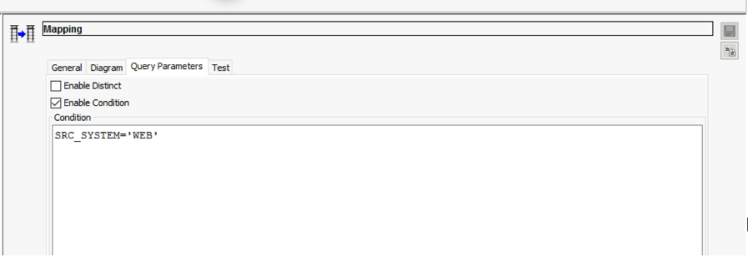

1.8 Project Architecture and Data Lifecycle

Data Flow Design
Data moves through the system in a structured sequence to ensure only high-quality "Golden Records" reach the final publishing area:
Landing Tables -> Staging Tables -> Base Objects

Stage Process
The Stage process acts as a bridge, moving data from raw Landing tables into source-specific Staging tables.
- Source Isolation: Each Base Object has three dedicated staging tables one for each source (WEB, AGY, PRT).
- Cleanse Approach: While standard MDM allows internal cleansing, this project performs major transformations (like Titlecasing and Email normalization) in the ETL layer to ensure the Hub remains highly performant.
Automatic Rejections during Staging: Records are automatically sent to Reject Tables if they fail basic integrity checks, such as:
- Invalid Reference: Gender codes not matching 'M', 'F', or 'U'.
- Format Errors: Passport numbers that do not follow the alphanumeric standard.
- Duplicate Source Keys: Multiple records sharing the same PKEY_SRC_OBJECT within the same batch.

Rejection handling in MDM Hub
Every staging table has a corresponding Reject Table. These tables store the reason for failure, allowing administrators to view and fix data issues within the Hub Console. Load-Time Rejections occur if:
- A record has a Null value in a mandatory field (e.g., Missing Last Name).
- A child record (Address/Contact) has an invalid foreign key that cannot be linked to a parent traveler.

Cleanse Functions and Mappings
Mappings define the specific path from a Landing column to a Staging column.
- Naming Convention: Mappings are prefixed for clarity, such as m_LND_to_STG_WEB_CUSTOMER.
- Source Filtering: Every mapping uses an Enable Condition (e.g., SRC_SYSTEM = 'WEB') to ensure it only picks relevant records from the landing zone.

Load process
The Load process moves validated data from Staging into the Base Objects (BO) to form the Master Record. Key Outcomes of a Load Job:
- New Records: Inserted into the Base Object and the Cross-Reference (XREF) table.
- Existing Records: If a traveler already exists, the XREF is updated with the latest information from that source.
- Survival (BVT): If multiple sources (WEB vs. AGY) provide different phone numbers, the Hub uses Trust Rules to decide which value survives in the "Golden Copy".

Diagram: Initial Data Load
Diagram: Incremental Load

During load process, if the new data overlaps with existing data in the MDM hub, the tool uses trust rules to determine which value will survive on the consolidated base record. All data changes are kept in cross-reference or history tables.
In MDM Hub, Records get loaded into Base Objects after the load Process.

Match Process
The process of comparing records within the Hub to determine if they are potential duplicates of each other is called Matching. By identifying these duplicates, the system can consolidate them into a single "Golden Copy" record..
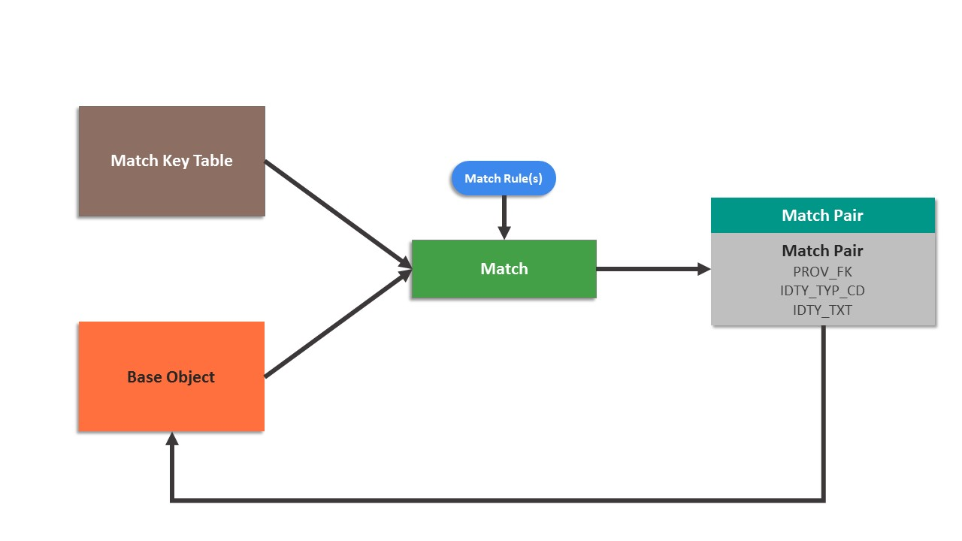
Diagram: Match Process

Match Columns
To execute the match, specific columns were selected and standardized to create Match Keys. These keys allow the Hub to find records even if they aren't identical (Fuzzy Matching).
- Person Name: High-level fuzzy matching for First and Last names.
- Passport Number: Used for Exact matching to ensure identity precision.
- Date of Birth: Used as a secondary filter to validate the match pair.

Match Rules
The requirement mandates a minimum of two match rules at the parent level: one Exact and one Fuzzy using a child column.

Rule | Match purpose | Rule type | Match Columns Used | Auto/Manual Merge
1 | Strict Identity Match | Exact | Exact_Passport + Exact_DOB | Auto Merge
2 | Cross-SystemVariation  Match | Fuzzy | Person_Name (Fuzzy) + Exact_Address_1(Child Column via Match Path) | Manual Merge

CUSTOMER MATCH/MERGE

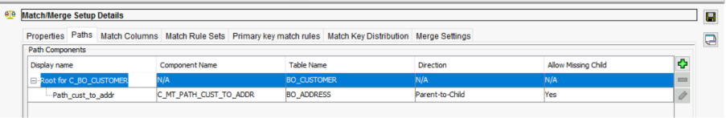

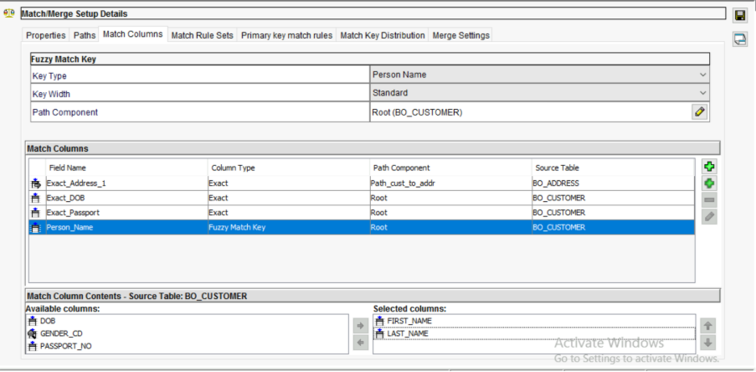

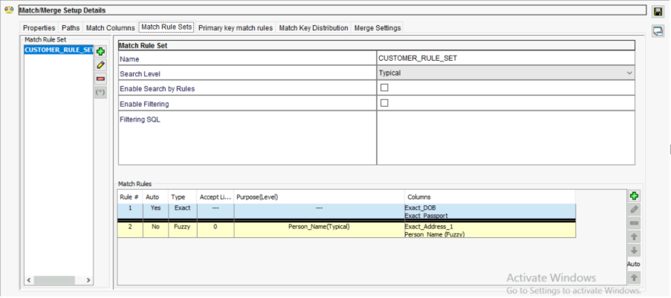

ADDRESS MATCH/MERGE

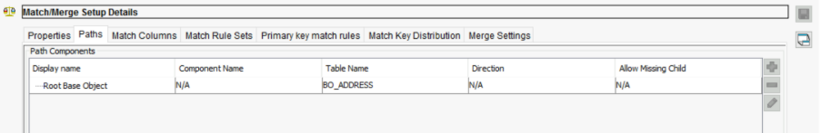

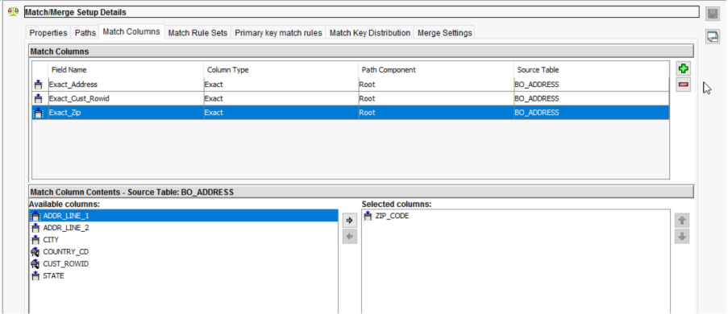

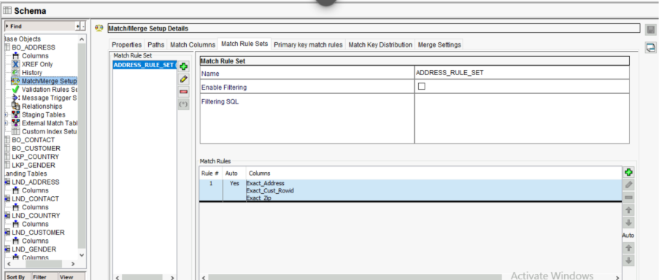

1.9 Trust Rules
Trust is the mechanism used by the Informatica MDM Hub to determine Survivorship. It evaluates the reliability of incoming data to decide which source's attribute becomes the "Best Version of the Truth" (BVT) in the Golden Record.

Trust Logic and Decay
- Survivorship: When two records are consolidated, the Hub compares the trust scores of each attribute. The value with the higher score survives in the Base Object.
- Validation Rules: Trust can be further refined by validation rules. For example, if a Phone Number is in an invalid format, its trust score can be downgraded to 0, allowing a lower-priority but valid source to win.
- Manual Updates: The Admin system is assigned the highest possible trust. This ensures that if a Data Steward manually corrects a traveler's name in IDD, that change is protected and cannot be overwritten by automated batch feeds.

- Trust Assignment by Source

- WEB (Highest Trust): Data entered directly by the traveler via the web portal is considered the most reliable.
- AGY (Medium Trust): Data from Travel Agencies is trusted but considered secondary to direct customer input.
- PRT (Lowest Trust): Partner Airline data is often used for discovery but is the first to be overwritten if conflicting data exists in WEB or AGY.

Parent Base Object: C_BO_CUSTOMER
Trust is critical here because this table holds the core identity of the frequent flyer. The
validation rules we defined earlier (DOB and Passport) will actively downgrade these
base scores if the data is poor.
Trusted Columns: FIRST_NAME, LAST_NAME, DOB, PASSPORT_NO

Source  System | Initial Trust  Score | Minimum Trust  Score | Decay  Period | Decay  Type
WEB(Online) | 90 | 85 | 12 Months | Linear
AGY (agency) | 80 | 70 | 12 Months | Linear
PRT (Partner) | 70 | 55 | 12 Months | Linear
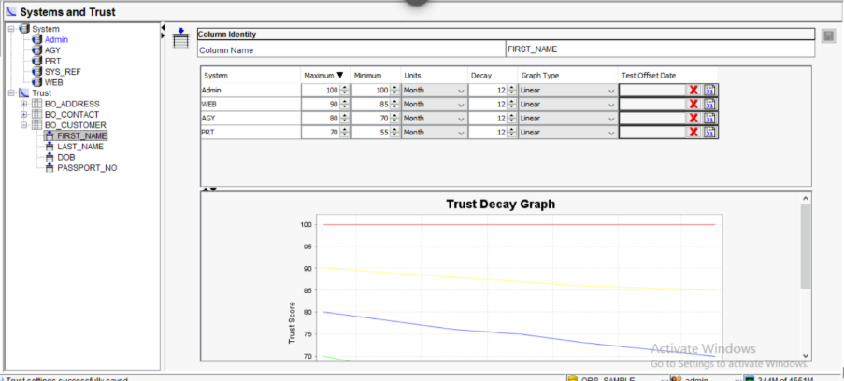

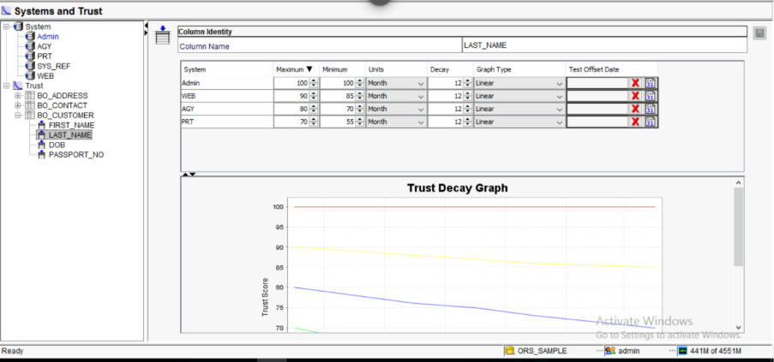

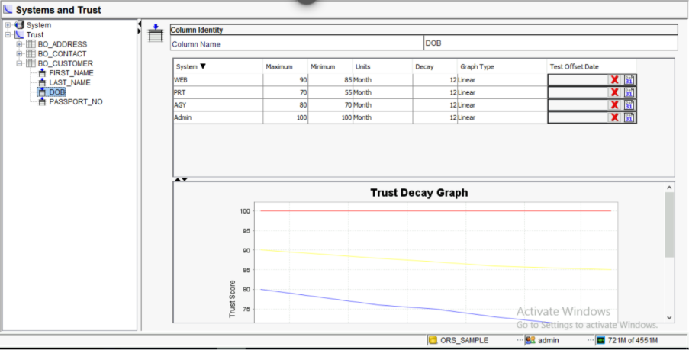

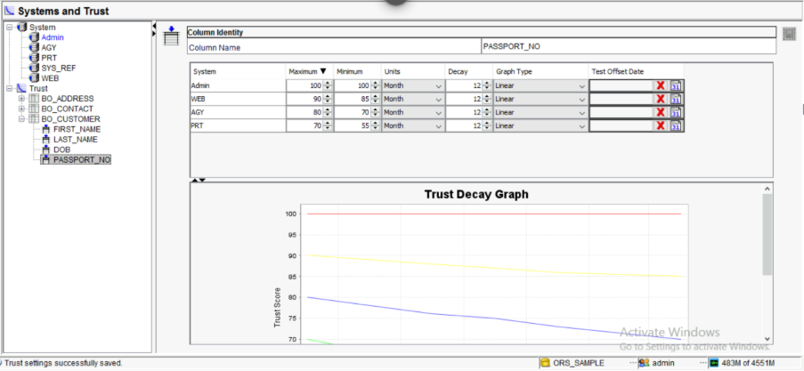

Child Base Object: C_BO_ADDRESS
Addresses change over time, so Trust and Decay are essential to ensure the most recent
and reliable address wins.
Trusted Columns: ADDR_LINE_1, CITY, ZIP_CODE

Source  System | Initial Trust  Score | Minimum Trust  Score | Decay  Period | Decay  Type
WEB(Online) | 90 | 85 | 24 Months | Linear
AGY (agency) | 80 | 70 | 24 Months | Linear
PRT (Partner) | 70 | 55 | 24 Months | Linear

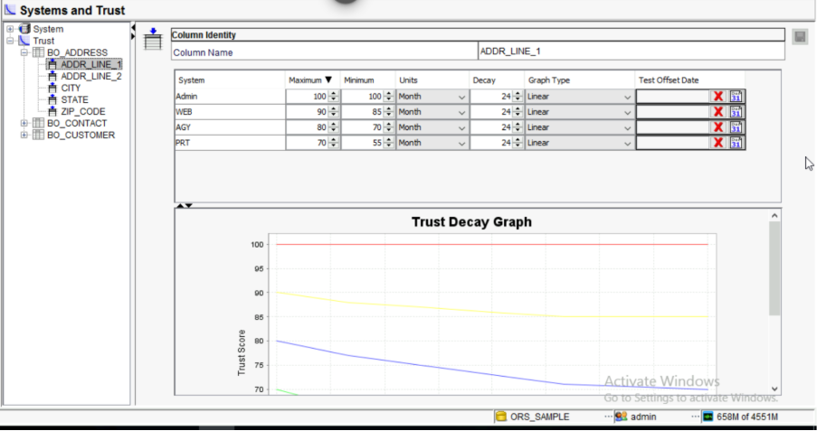

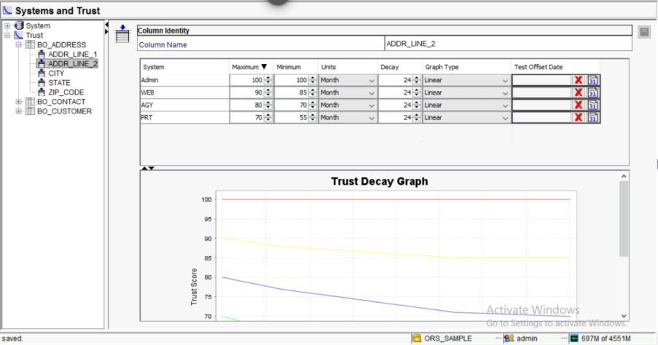

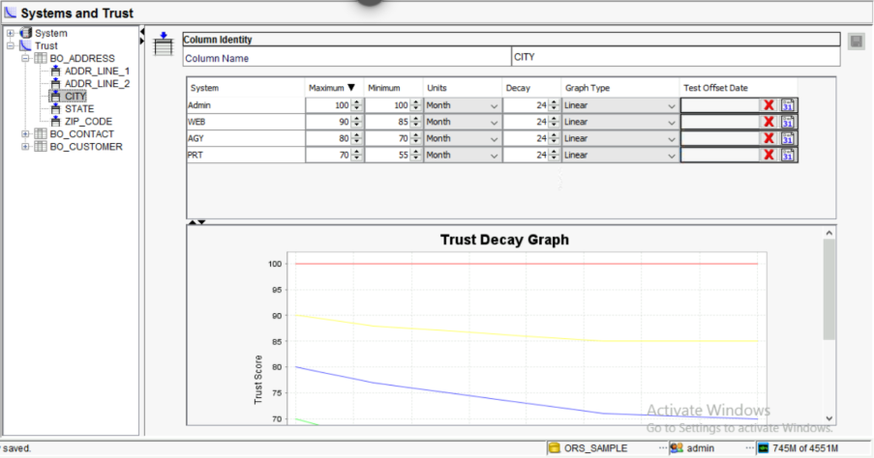

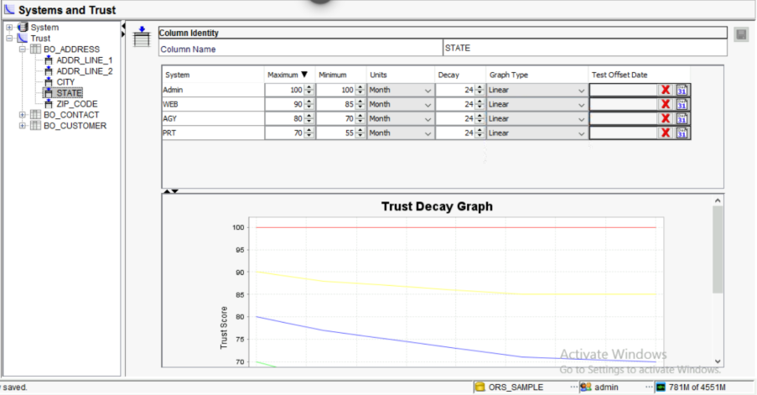

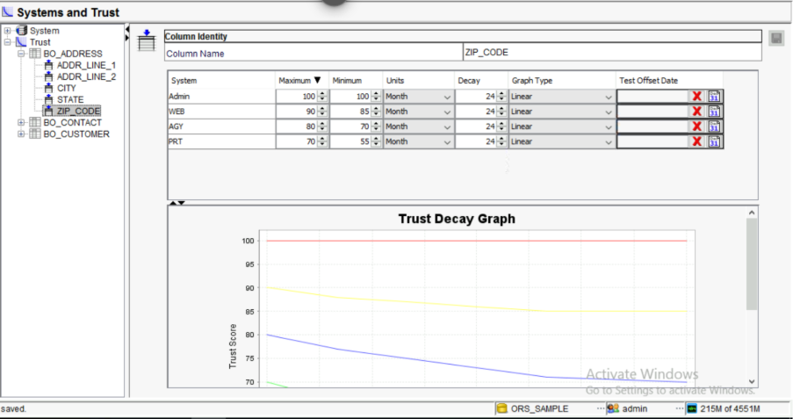

Child Base Object: C_BO_CONTACT
Contact information becomes outdated very quickly. We apply an aggressive decay
schedule here.
Trusted Columns: EMAIL, PHONE_NUMBER

Source  System | Initial Trust  Score | Minimum Trust  Score | Decay  Period | Decay  Type
WEB(Online) | 90 | 85 | 6 Months | Linear
AGY (agency) | 80 | 70 | 6 Months | Linear
PRT (Partner) | 70 | 55 | 6 Months | Linear

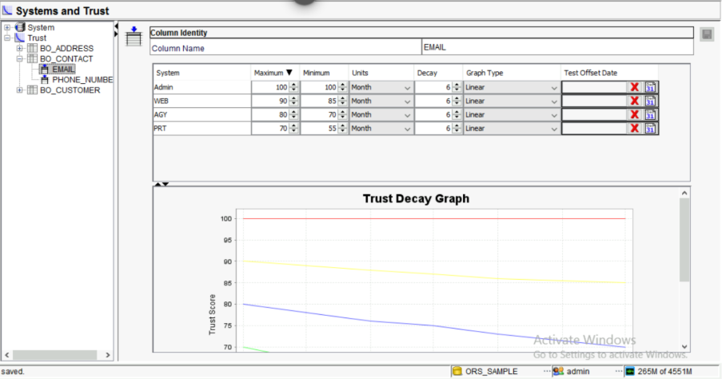

1.10 Batch Job Execution and Monitoring

- STAGE JOB

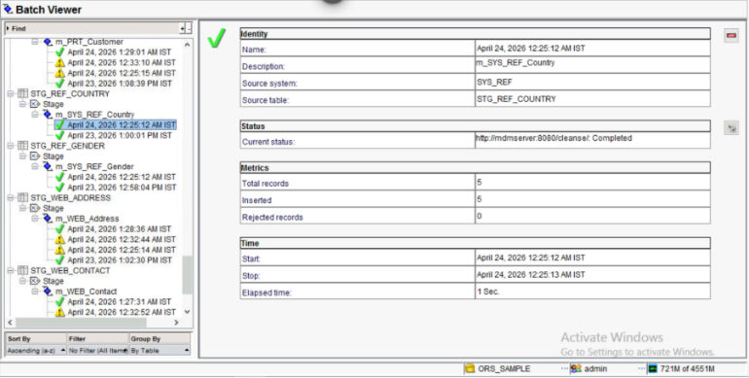

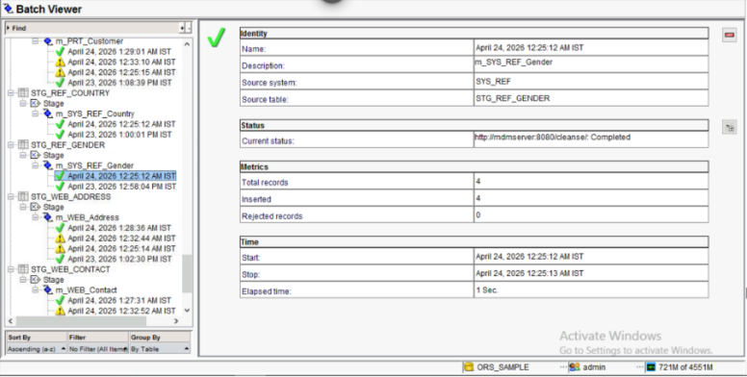

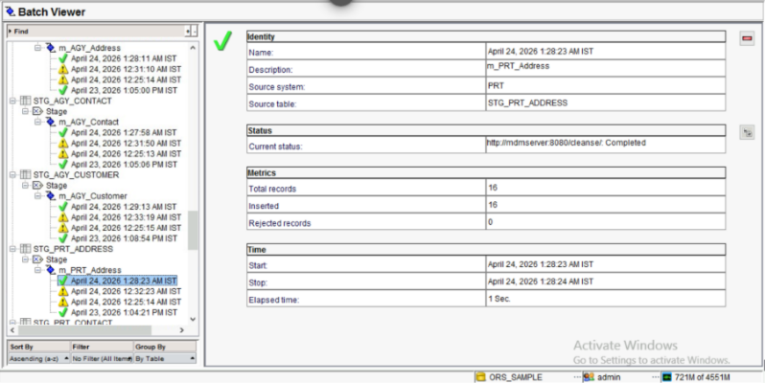

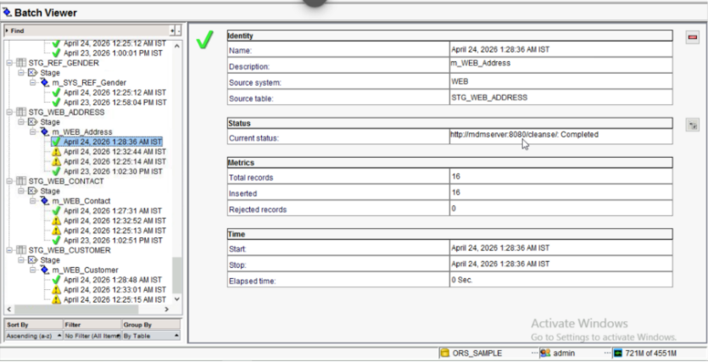

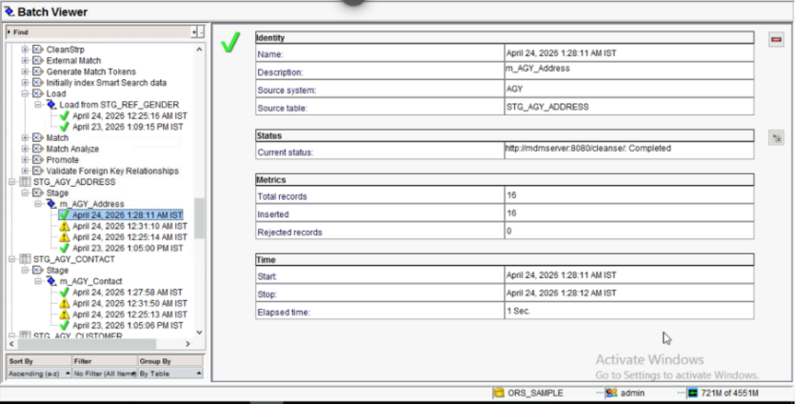

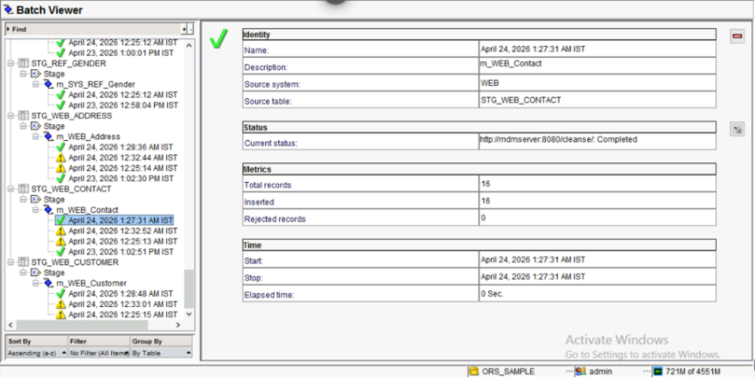

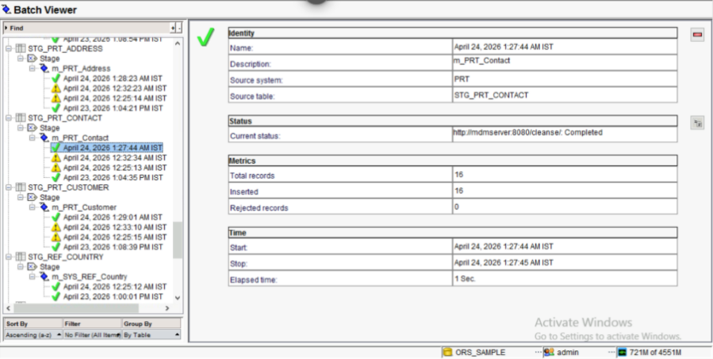

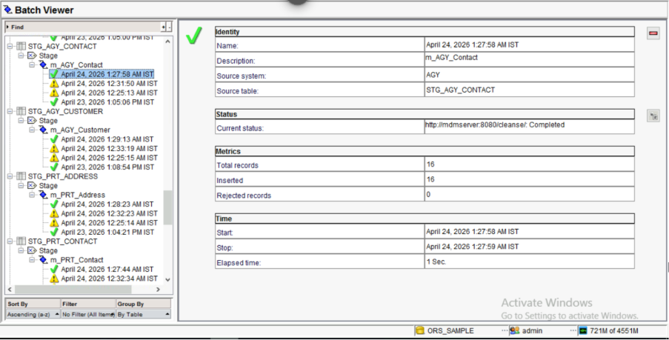

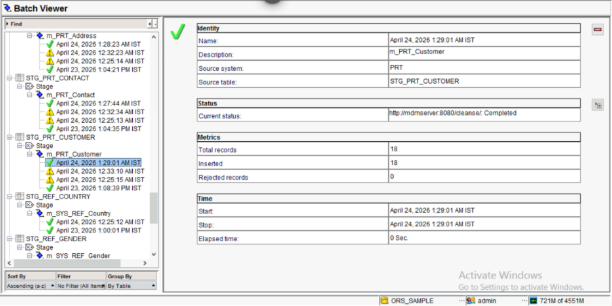
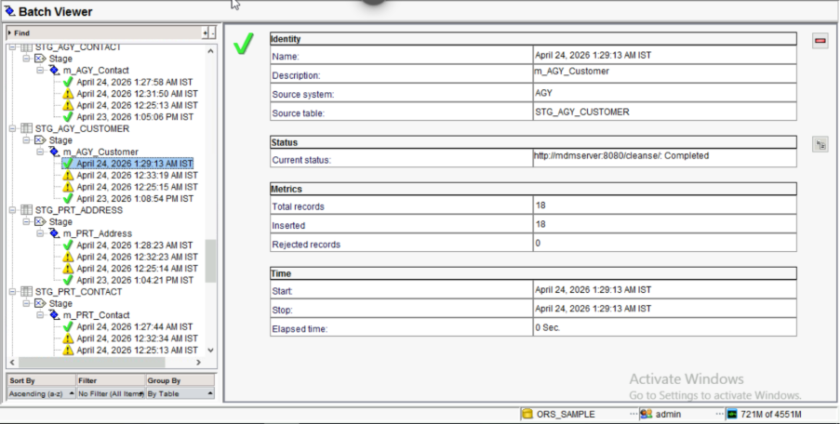

- LOAD JOBS

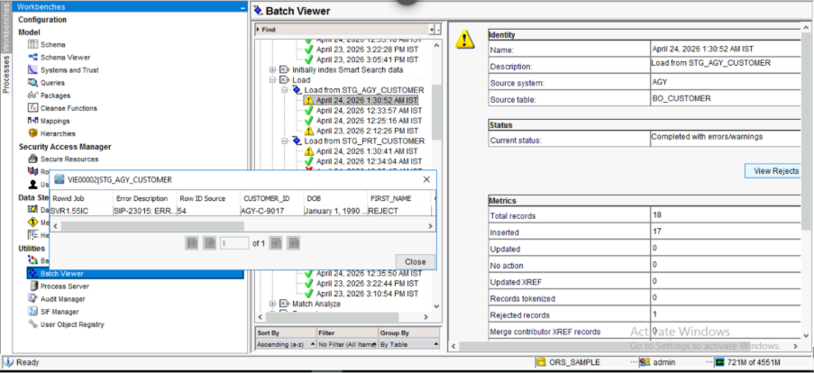

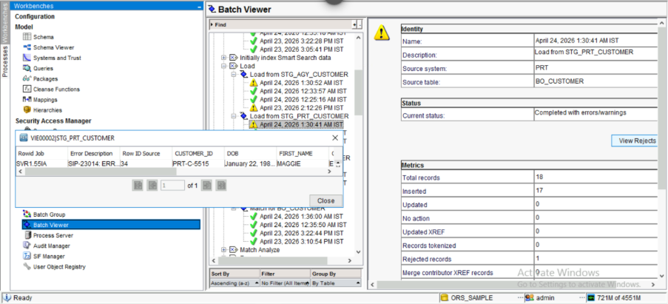
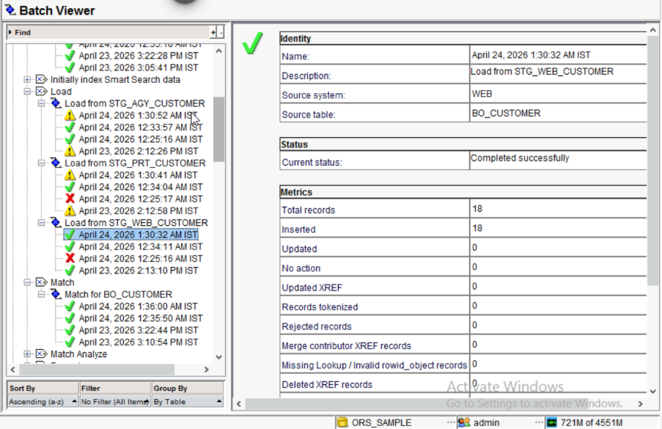

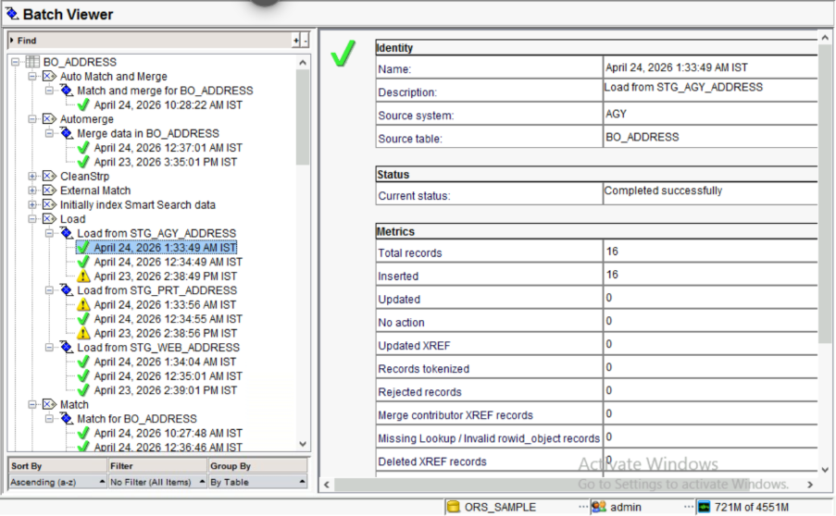
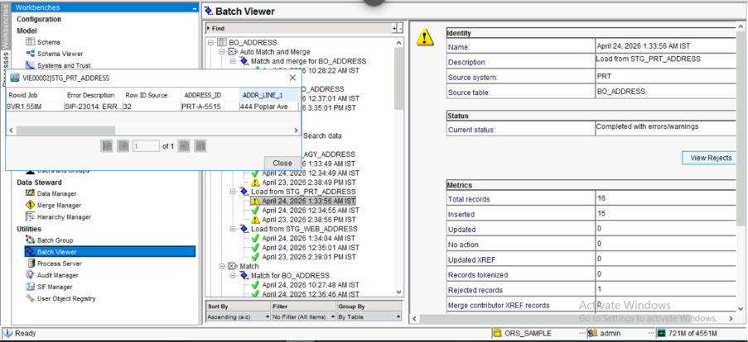

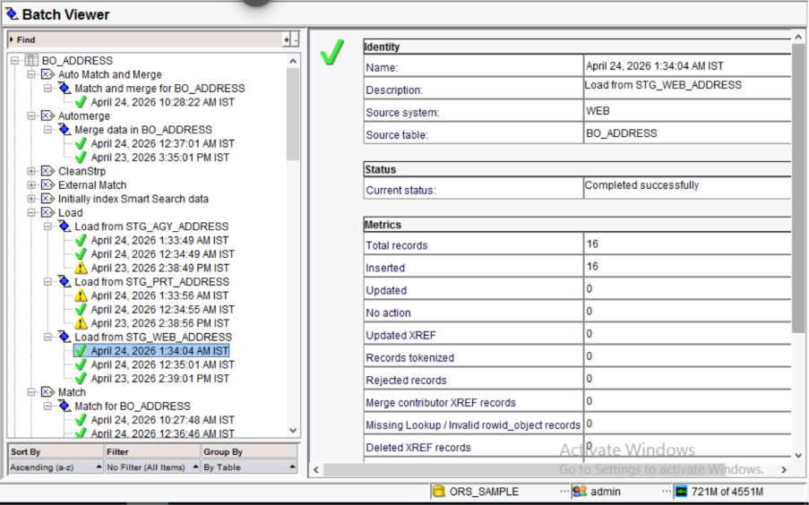

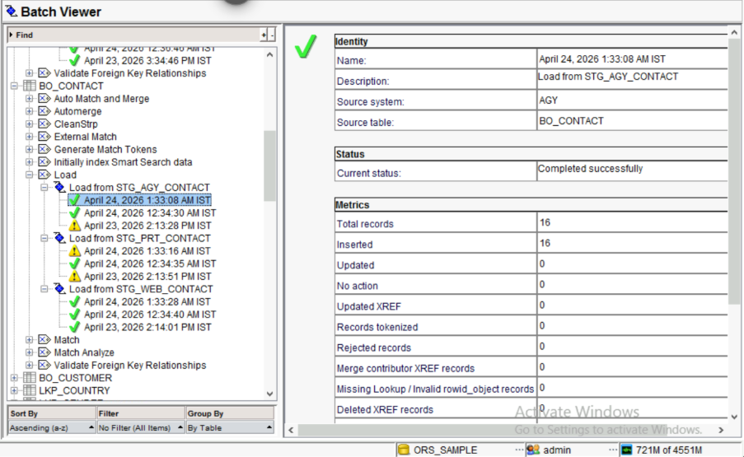

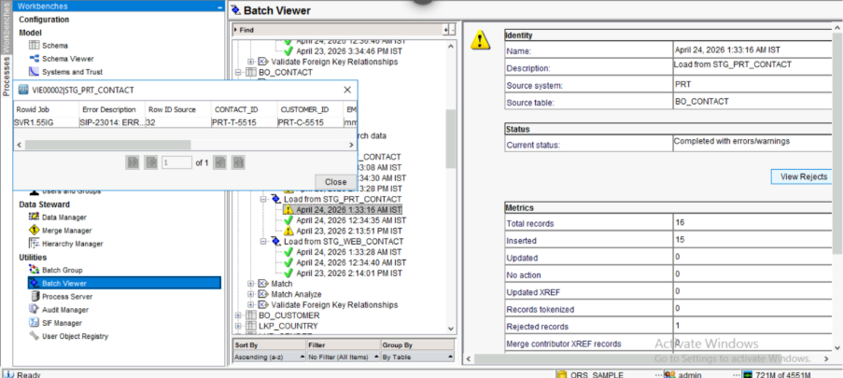

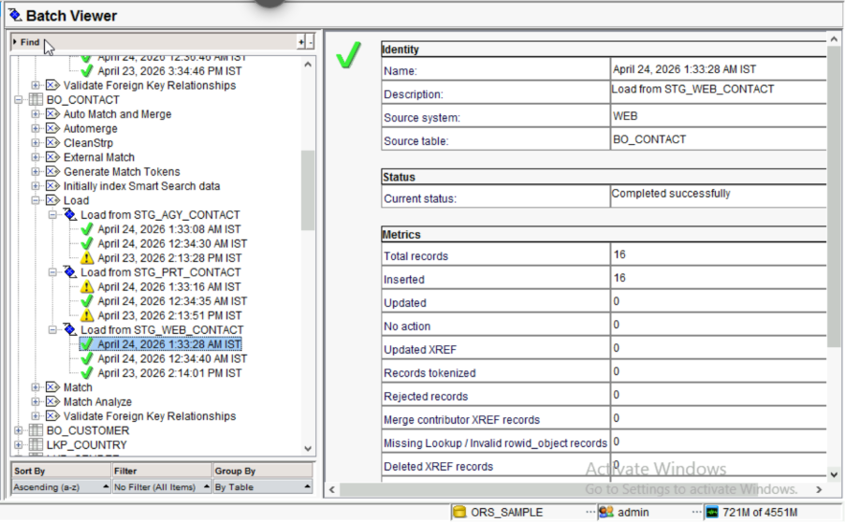

- TOKENIZATION PROCESS

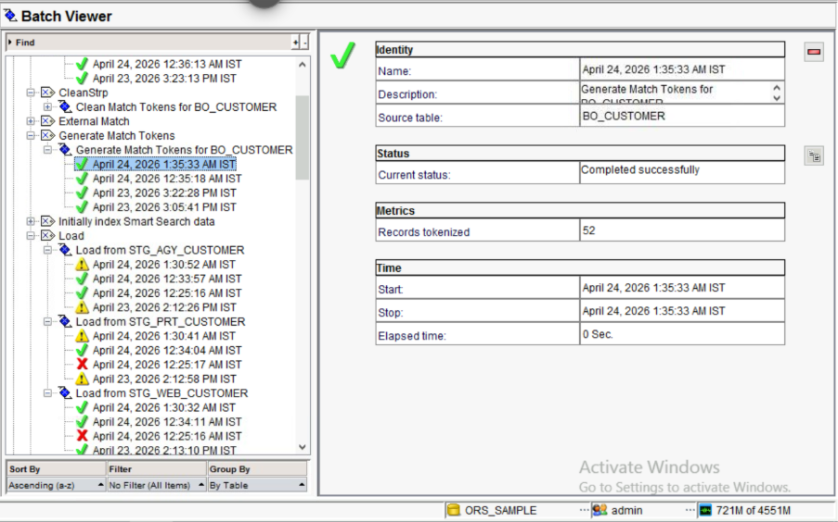

- MATCH AND MERGE PROCESS

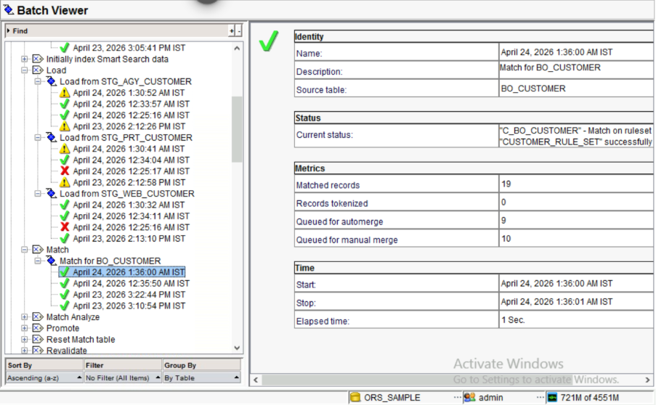

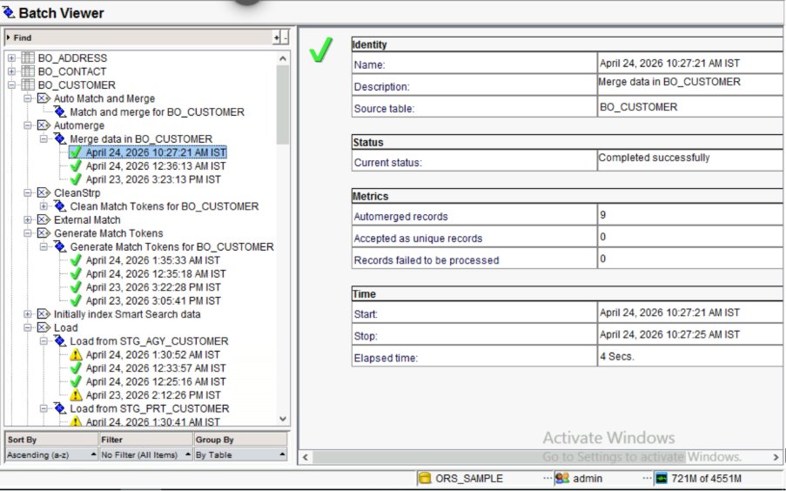

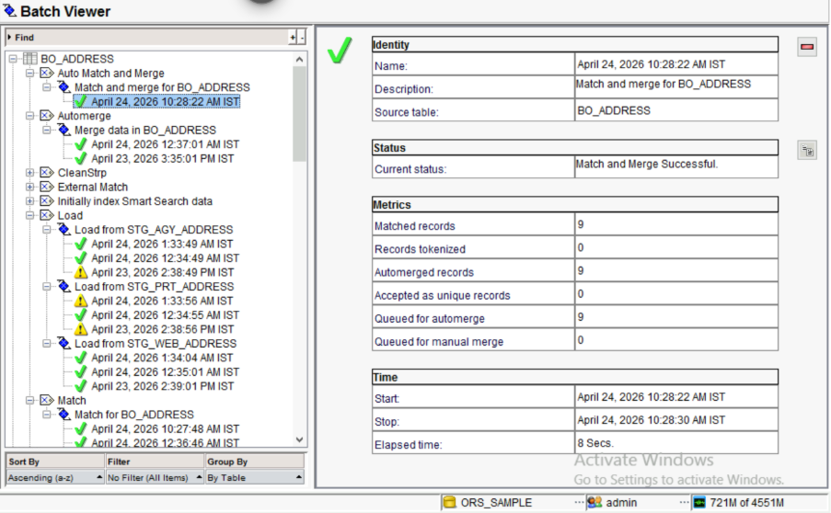

1.11 Queries (Landing table insert statements)

INSERT INTO C_LND_GENDER (GENDER_CD, GENDER_DESC, LAST_UPDATE_DATE, SRC_SYSTEM) VALUES ('M', 'Male', CAST('2026-04-23' AS DATE), 'SYS_REF');
INSERT INTO C_LND_GENDER (GENDER_CD, GENDER_DESC, LAST_UPDATE_DATE, SRC_SYSTEM) VALUES ('F', 'Female', CAST('2026-04-23' AS DATE), 'SYS_REF');
INSERT INTO C_LND_GENDER (GENDER_CD, GENDER_DESC, LAST_UPDATE_DATE, SRC_SYSTEM) VALUES ('X', 'Unspecified', CAST('2026-04-23' AS DATE), 'SYS_REF');
INSERT INTO C_LND_GENDER (GENDER_CD, GENDER_DESC, LAST_UPDATE_DATE, SRC_SYSTEM) VALUES ('P', 'Prefer Not to Say', CAST('2026-04-23' AS DATE), 'SYS_REF');
INSERT INTO C_LND_COUNTRY (COUNTRY_CD, COUNTRY_NAME, LAST_UPDATE_DATE, SRC_SYSTEM) VALUES ('US', 'United States', CAST('2026-04-23' AS DATE), 'SYS_REF');
INSERT INTO C_LND_COUNTRY (COUNTRY_CD, COUNTRY_NAME, LAST_UPDATE_DATE, SRC_SYSTEM) VALUES ('CA', 'Canada', CAST('2026-04-23' AS DATE), 'SYS_REF');
INSERT INTO C_LND_COUNTRY (COUNTRY_CD, COUNTRY_NAME, LAST_UPDATE_DATE, SRC_SYSTEM) VALUES ('GB', 'United Kingdom', CAST('2026-04-23' AS DATE), 'SYS_REF');
INSERT INTO C_LND_COUNTRY (COUNTRY_CD, COUNTRY_NAME, LAST_UPDATE_DATE, SRC_SYSTEM) VALUES ('IN', 'India', CAST('2026-04-23' AS DATE), 'SYS_REF');
INSERT INTO C_LND_COUNTRY (COUNTRY_CD, COUNTRY_NAME, LAST_UPDATE_DATE, SRC_SYSTEM) VALUES ('AU', 'Australia', CAST('2026-04-23' AS DATE), 'SYS_REF');
INSERT INTO C_LND_ADDRESS (ADDRESS_ID, CUSTOMER_ID, ADDR_LINE_1, ADDR_LINE_2, CITY, STATE, ZIP_CODE, COUNTRY, LAST_UPDATE_DATE, SRC_SYSTEM) VALUES
('WEB-A-1000', 'WEB-C-1000', '123 Maple St', NULL, 'NEW YORK', 'NY', '10001', 'US', CAST('2026-04-23' AS DATE), 'WEB'),
('WEB-A-1001', 'WEB-C-1001', '456 Oak Ave', NULL, 'LOS ANGELES', 'CA', '90001', 'US', CAST('2026-04-23' AS DATE), 'WEB'),
('WEB-A-1002', 'WEB-C-1002', '789 Pine Rd', NULL, 'CHICAGO', 'IL', '60601', 'US', CAST('2026-04-23' AS DATE), 'WEB'),
('WEB-A-1003', 'WEB-C-1003', '321 Cedar Ln', NULL, 'HOUSTON', 'TX', '77001', 'US', CAST('2026-04-23' AS DATE), 'WEB'),
('WEB-A-1004', 'WEB-C-1004', '654 Birch Blvd', NULL, 'PHOENIX', 'AZ', '85001', 'US', CAST('2026-04-23' AS DATE), 'WEB'),
('WEB-A-1005', 'WEB-C-1005', '987 Walnut St', NULL, 'PHILADELPHIA', 'PA', '19101', 'US', CAST('2026-04-23' AS DATE), 'WEB'),
('WEB-A-1006', 'WEB-C-1006', '147 Cherry Ct', NULL, 'SAN ANTONIO', 'TX', '78201', 'US', CAST('2026-04-23' AS DATE), 'WEB'),
('WEB-A-1007', 'WEB-C-1007', '258 Elm St', NULL, 'SAN DIEGO', 'CA', '92101', 'US', CAST('2026-04-23' AS DATE), 'WEB'),
('WEB-A-1008', 'WEB-C-1008', '888 Ash Dr', NULL, 'DENVER', 'CO', '80201', 'US', CAST('2026-04-23' AS DATE), 'WEB'),
('WEB-A-1009', 'WEB-C-1009', '999 Fir Blvd', NULL, 'BOSTON', 'MA', '02101', 'US', CAST('2026-04-23' AS DATE), 'WEB'),
('WEB-A-1010', 'WEB-C-1010', '111 Redwood Ln', NULL, 'DETROIT', 'MI', '48201', 'US', CAST('2026-04-23' AS DATE), 'WEB'),
('WEB-A-1011', 'WEB-C-1011', '222 Palm Ct', NULL, 'MIAMI', 'FL', '33101', 'US', CAST('2026-04-23' AS DATE), 'WEB'),
('WEB-A-1012', 'WEB-C-1012', '333 Cypress St', NULL, 'DALLAS', 'TX', '75201', 'US', CAST('2026-04-23' AS DATE), 'WEB'),
('WEB-A-1013', 'WEB-C-1013', '555 Cedar St', NULL, 'ATLANTA', 'GA', '30301', 'US', CAST('2026-04-23' AS DATE), 'WEB'),
('WEB-A-1014', 'WEB-C-1014', '777 Spruce Way', NULL, 'SEATTLE', 'WA', '98101', 'US', CAST('2026-04-23' AS DATE), 'WEB'),
('WEB-A-1015', 'WEB-C-1015', '444 Poplar Ave', NULL, 'SAN FRANCISCO', 'CA', '94101', 'US', CAST('2026-04-23' AS DATE), 'WEB'),
('PRT-A-5500', 'PRT-C-5500', '123 Maple St', NULL, 'NEW YORK', 'NY', '10001', 'US', CAST('2026-04-23' AS DATE), 'PRT'),
('PRT-A-5501', 'PRT-C-5501', '456 Oak Ave', NULL, 'LOS ANGELES', 'CA', '90001', 'US', CAST('2026-04-23' AS DATE), 'PRT'),
('PRT-A-5502', 'PRT-C-5502', '789 Pine Rd', NULL, 'CHICAGO', 'IL', '60601', 'US', CAST('2026-04-23' AS DATE), 'PRT'),
('PRT-A-5503', 'PRT-C-5503', '321 Cedar Ln', NULL, 'HOUSTON', 'TX', '77001', 'US', CAST('2026-04-23' AS DATE), 'PRT'),
('PRT-A-5504', 'PRT-C-5504', '654 Birch Blvd', NULL, 'PHOENIX', 'AZ', '85001', 'US', CAST('2026-04-23' AS DATE), 'PRT'),
('PRT-A-5505', 'PRT-C-5505', '987 Walnut St', NULL, 'PHILADELPHIA', 'PA', '19101', 'US', CAST('2026-04-23' AS DATE), 'PRT'),
('PRT-A-5506', 'PRT-C-5506', '147 Cherry Ct', NULL, 'SAN ANTONIO', 'TX', '78201', 'US', CAST('2026-04-23' AS DATE), 'PRT'),
('PRT-A-5507', 'PRT-C-5507', '258 Elm St', NULL, 'SAN DIEGO', 'CA', '92101', 'US', CAST('2026-04-23' AS DATE), 'PRT'),
('PRT-A-5508', 'PRT-C-5508', '888 Ash Dr', NULL, 'DENVER', 'CO', '80201', 'US', CAST('2026-04-23' AS DATE), 'PRT'),
('PRT-A-5509', 'PRT-C-5509', '999 Fir Blvd', NULL, 'BOSTON', 'MA', '02101', 'US', CAST('2026-04-23' AS DATE), 'PRT'),
('PRT-A-5510', 'PRT-C-5510', '111 Redwood Ln', NULL, 'DETROIT', 'MI', '48201', 'US', CAST('2026-04-23' AS DATE), 'PRT'),
('PRT-A-5511', 'PRT-C-5511', '222 Palm Ct', NULL, 'MIAMI', 'FL', '33101', 'US', CAST('2026-04-23' AS DATE), 'PRT'),
('PRT-A-5512', 'PRT-C-5512', '333 Cypress St', NULL, 'DALLAS', 'TX', '75201', 'US', CAST('2026-04-23' AS DATE), 'PRT'),
('PRT-A-5513', 'PRT-C-5513', '555 Cedar St', NULL, 'ATLANTA', 'GA', '30301', 'US', CAST('2026-04-23' AS DATE), 'PRT'),
('PRT-A-5514', 'PRT-C-5514', '777 Spruce Way', NULL, 'SEATTLE', 'WA', '98101', 'US', CAST('2026-04-23' AS DATE), 'PRT'),
('PRT-A-5515', 'PRT-C-5515', '444 Poplar Ave', NULL, 'SAN FRANCISCO', 'CA', '94101', 'US', CAST('2026-04-23' AS DATE), 'PRT'),
('AGY-A-9000', 'AGY-C-9000', '123 Maple St', 'Suite 100', 'NEW YORK', 'NY', '10001', 'US', CAST('2026-04-23' AS DATE), 'AGY'),
('AGY-A-9001', 'AGY-C-9001', '456 Oak Ave', 'Suite 100', 'LOS ANGELES', 'CA', '90001', 'US', CAST('2026-04-23' AS DATE), 'AGY'),
('AGY-A-9002', 'AGY-C-9002', '789 Pine Rd', 'Suite 100', 'CHICAGO', 'IL', '60601', 'US', CAST('2026-04-23' AS DATE), 'AGY'),
('AGY-A-9003', 'AGY-C-9003', '321 Cedar Ln', 'Suite 100', 'HOUSTON', 'TX', '77001', 'US', CAST('2026-04-23' AS DATE), 'AGY'),
('AGY-A-9004', 'AGY-C-9004', '654 Birch Blvd', 'Suite 100', 'PHOENIX', 'AZ', '85001', 'US', CAST('2026-04-23' AS DATE), 'AGY'),
('AGY-A-9005', 'AGY-C-9005', '987 Walnut St', 'Suite 100', 'PHILADELPHIA', 'PA', '19101', 'US', CAST('2026-04-23' AS DATE), 'AGY'),
('AGY-A-9006', 'AGY-C-9006', '147 Cherry Ct', 'Suite 100', 'SAN ANTONIO', 'TX', '78201', 'US', CAST('2026-04-23' AS DATE), 'AGY'),
('AGY-A-9007', 'AGY-C-9007', '258 Elm St', 'Suite 100', 'SAN DIEGO', 'CA', '92101', 'US', CAST('2026-04-23' AS DATE), 'AGY'),
('AGY-A-9008', 'AGY-C-9008', '888 Ash Dr', 'Suite 100', 'DENVER', 'CO', '80201', 'US', CAST('2026-04-23' AS DATE), 'AGY'),
('AGY-A-9009', 'AGY-C-9009', '999 Fir Blvd', 'Suite 100', 'BOSTON', 'MA', '02101', 'US', CAST('2026-04-23' AS DATE), 'AGY'),
('AGY-A-9010', 'AGY-C-9010', '111 Redwood Ln', 'Suite 100', 'DETROIT', 'MI', '48201', 'US', CAST('2026-04-23' AS DATE), 'AGY'),
('AGY-A-9011', 'AGY-C-9011', '222 Palm Ct', 'Suite 100', 'MIAMI', 'FL', '33101', 'US', CAST('2026-04-23' AS DATE), 'AGY'),
('AGY-A-9012', 'AGY-C-9012', '333 Cypress St', 'Suite 100', 'DALLAS', 'TX', '75201', 'US', CAST('2026-04-23' AS DATE), 'AGY'),
('AGY-A-9013', 'AGY-C-9013', '555 Cedar St', 'Suite 100', 'ATLANTA', 'GA', '30301', 'US', CAST('2026-04-23' AS DATE), 'AGY'),
('AGY-A-9014', 'AGY-C-9014', '777 Spruce Way', 'Suite 100', 'SEATTLE', 'WA', '98101', 'US', CAST('2026-04-23' AS DATE), 'AGY'),
('AGY-A-9015', 'AGY-C-9015', '444 Poplar Ave', 'Suite 100', 'SAN FRANCISCO', 'CA', '94101', 'US', CAST('2026-04-23' AS DATE), 'AGY');
INSERT INTO C_LND_CONTACT (CONTACT_ID, CUSTOMER_ID, EMAIL, PHONE_NUMBER, LAST_UPDATE_DATE, SRC_SYSTEM) VALUES
('WEB-T-1000', 'WEB-C-1000', 'john.doe@email.com', '2125551234', CAST('2026-04-23' AS DATE), 'WEB'),
('WEB-T-1001', 'WEB-C-1001', 'alice.s@email.com', '2135559876', CAST('2026-04-23' AS DATE), 'WEB'),
('WEB-T-1002', 'WEB-C-1002', 'robertj@email.com', '3125554321', CAST('2026-04-23' AS DATE), 'WEB'),
('WEB-T-1003', 'WEB-C-1003', 'edavis88@email.com', '7135558765', CAST('2026-04-23' AS DATE), 'WEB'),
('WEB-T-1004', 'WEB-C-1004', 'mbrown@email.com', '6025553456', CAST('2026-04-23' AS DATE), 'WEB'),
('WEB-T-1005', 'WEB-C-1005', 'sarah.w@email.com', '2155556543', CAST('2026-04-23' AS DATE), 'WEB'),
('WEB-T-1006', 'WEB-C-1006', 'dmartinez@email.com', '2105557890', CAST('2026-04-23' AS DATE), 'WEB'),
('WEB-T-1007', 'WEB-C-1007', 'jenn.a@email.com', '6195550987', CAST('2026-04-23' AS DATE), 'WEB'),
('WEB-T-1008', 'WEB-C-1008', 'ewhite@email.com', '3035555566', CAST('2026-04-23' AS DATE), 'WEB'),
('WEB-T-1009', 'WEB-C-1009', 'rwhite@email.com', '6175557788', CAST('2026-04-23' AS DATE), 'WEB'),
('WEB-T-1010', 'WEB-C-1010', 'pgarcia@email.com', '3135559900', CAST('2026-04-23' AS DATE), 'WEB'),
('WEB-T-1011', 'WEB-C-1011', 'jjackson@email.com', '3055552233', CAST('2026-04-23' AS DATE), 'WEB'),
('WEB-T-1012', 'WEB-C-1012', 'jthompson@email.com', '2145554455', CAST('2026-04-23' AS DATE), 'WEB'),
('WEB-T-1013', 'WEB-C-1013', 'will.j@email.com', '4045551122', CAST('2026-04-23' AS DATE), 'WEB'),
('WEB-T-1014', 'WEB-C-1014', 'charris@email.com', '2065553344', CAST('2026-04-23' AS DATE), 'WEB'),
('WEB-T-1015', 'WEB-C-1015', 'mmartin@email.com', '4155556677', CAST('2026-04-23' AS DATE), 'WEB'),
('PRT-T-5500', 'PRT-C-5500', 'john.doe@email.com', '2125551234', CAST('2026-04-23' AS DATE), 'PRT'),
('PRT-T-5501', 'PRT-C-5501', NULL, '2135559876', CAST('2026-04-23' AS DATE), 'PRT'),
('PRT-T-5502', 'PRT-C-5502', NULL, '3125554321', CAST('2026-04-23' AS DATE), 'PRT'),
('PRT-T-5503', 'PRT-C-5503', 'edavis88@email.com', '7135558765', CAST('2026-04-23' AS DATE), 'PRT'),
('PRT-T-5504', 'PRT-C-5504', NULL, '6025553456', CAST('2026-04-23' AS DATE), 'PRT'),
('PRT-T-5505', 'PRT-C-5505', NULL, '2155556543', CAST('2026-04-23' AS DATE), 'PRT'),
('PRT-T-5506', 'PRT-C-5506', 'dmartinez@email.com', '2105557890', CAST('2026-04-23' AS DATE), 'PRT'),
('PRT-T-5507', 'PRT-C-5507', NULL, '6195550987', CAST('2026-04-23' AS DATE), 'PRT'),
('PRT-T-5508', 'PRT-C-5508', NULL, '3035555566', CAST('2026-04-23' AS DATE), 'PRT'),
('PRT-T-5509', 'PRT-C-5509', 'rwhite@email.com', '6175557788', CAST('2026-04-23' AS DATE), 'PRT'),
('PRT-T-5510', 'PRT-C-5510', NULL, '3135559900', CAST('2026-04-23' AS DATE), 'PRT'),
('PRT-T-5511', 'PRT-C-5511', NULL, '3055552233', CAST('2026-04-23' AS DATE), 'PRT'),
('PRT-T-5512', 'PRT-C-5512', 'jthompson@email.com', '2145554455', CAST('2026-04-23' AS DATE), 'PRT'),
('PRT-T-5513', 'PRT-C-5513', NULL, '4045551122', CAST('2026-04-23' AS DATE), 'PRT'),
('PRT-T-5514', 'PRT-C-5514', NULL, '2065553344', CAST('2026-04-23' AS DATE), 'PRT'),
('PRT-T-5515', 'PRT-C-5515', 'mmartin@email.com', '4155556677', CAST('2026-04-23' AS DATE), 'PRT'),
('AGY-T-9000', 'AGY-C-9000', 'john.doe@email.com', '2125551234', CAST('2026-04-23' AS DATE), 'AGY'),
('AGY-T-9001', 'AGY-C-9001', NULL, '2135559876', CAST('2026-04-23' AS DATE), 'AGY'),
('AGY-T-9002', 'AGY-C-9002', 'robertj@email.com', '3125554321', CAST('2026-04-23' AS DATE), 'AGY'),
('AGY-T-9003', 'AGY-C-9003', NULL, '7135558765', CAST('2026-04-23' AS DATE), 'AGY'),
('AGY-T-9004', 'AGY-C-9004', 'mbrown@email.com', '6025553456', CAST('2026-04-23' AS DATE), 'AGY'),
('AGY-T-9005', 'AGY-C-9005', NULL, '2155556543', CAST('2026-04-23' AS DATE), 'AGY'),
('AGY-T-9006', 'AGY-C-9006', 'dmartinez@email.com', '2105557890', CAST('2026-04-23' AS DATE), 'AGY'),
('AGY-T-9007', 'AGY-C-9007', NULL, '6195550987', CAST('2026-04-23' AS DATE), 'AGY'),
('AGY-T-9008', 'AGY-C-9008', 'ewhite@email.com', '3035555566', CAST('2026-04-23' AS DATE), 'AGY'),
('AGY-T-9009', 'AGY-C-9009', NULL, '6175557788', CAST('2026-04-23' AS DATE), 'AGY'),
('AGY-T-9010', 'AGY-C-9010', 'pgarcia@email.com', '3135559900', CAST('2026-04-23' AS DATE), 'AGY'),
('AGY-T-9011', 'AGY-C-9011', NULL, '3055552233', CAST('2026-04-23' AS DATE), 'AGY'),
('AGY-T-9012', 'AGY-C-9012', 'jthompson@email.com', '2145554455', CAST('2026-04-23' AS DATE), 'AGY'),
('AGY-T-9013', 'AGY-C-9013', NULL, '4045551122', CAST('2026-04-23' AS DATE), 'AGY'),
('AGY-T-9014', 'AGY-C-9014', 'charris@email.com', '2065553344', CAST('2026-04-23' AS DATE), 'AGY'),
('AGY-T-9015', 'AGY-C-9015', NULL, '4155556677', CAST('2026-04-23' AS DATE), 'AGY');
INSERT INTO C_LND_CUSTOMER (CUSTOMER_ID, FIRST_NAME, LAST_NAME, DOB, PASSPORT_NO, GENDER, LAST_UPDATE_DATE, SRC_SYSTEM) VALUES
('WEB-C-1000', 'JOHN', 'DOE', CAST('1980-05-15' AS DATE), 'P1234567', 'M', CAST('2026-04-23' AS DATE), 'WEB'),
('WEB-C-1001', 'ALICE', 'SMITH', CAST('1990-08-22' AS DATE), 'A9876543', 'F', CAST('2026-04-23' AS DATE), 'WEB'),
('WEB-C-1002', 'ROBERT', 'JOHNSON', CAST('1975-11-30' AS DATE), 'R5556667', 'M', CAST('2026-04-23' AS DATE), 'WEB'),
('WEB-C-1003', 'EMILY', 'DAVIS', CAST('1988-03-14' AS DATE), 'E1122334', 'F', CAST('2026-04-23' AS DATE), 'WEB'),
('WEB-C-1004', 'MICHAEL', 'BROWN', CAST('1992-07-09' AS DATE), 'M9988776', 'M', CAST('2026-04-23' AS DATE), 'WEB'),
('WEB-C-1005', 'SARAH', 'WILSON', CAST('1985-12-01' AS DATE), 'S4455667', 'F', CAST('2026-04-23' AS DATE), 'WEB'),
('WEB-C-1006', 'DAVID', 'MARTINEZ', CAST('1978-09-18' AS DATE), 'D7766554', 'M', CAST('2026-04-23' AS DATE), 'WEB'),
('WEB-C-1007', 'JENNIFER', 'ANDERSON', CAST('1995-04-25' AS DATE), 'J3344556', 'F', CAST('2026-04-23' AS DATE), 'WEB'),
('WEB-C-1008', 'ELIZABET', 'WHITE', CAST('1980-09-06' AS DATE), 'W0130864', 'F', CAST('2026-04-23' AS DATE), 'WEB'),
('WEB-C-1009', 'RICHARD', 'WHITE', CAST('1963-10-17' AS DATE), 'W2463548', 'M', CAST('2026-04-23' AS DATE), 'WEB'),
('WEB-C-1010', 'PATRICIA', 'GARCIA', CAST('1999-10-06' AS DATE), 'G6028965', 'F', CAST('2026-04-23' AS DATE), 'WEB'),
('WEB-C-1011', 'JOSEPH', 'JACKSON', CAST('1978-05-07' AS DATE), 'J1035605', 'M', CAST('2026-04-23' AS DATE), 'WEB'),
('WEB-C-1012', 'JESSICA', 'THOMPSON', CAST('1960-01-28' AS DATE), 'T6035566', 'F', CAST('2026-04-23' AS DATE), 'WEB'),
('WEB-C-1013', 'WILLIAM', 'JACKSON', CAST('1982-02-14' AS DATE), 'W99013', 'M', CAST('2026-04-23' AS DATE), 'WEB'),
('WEB-C-1014', 'CHRISTOP', 'HARRIS', CAST('1991-06-19' AS DATE), 'W99014', 'M', CAST('2026-04-23' AS DATE), 'WEB'),
('WEB-C-1015', 'MARGARET', 'MARTIN', CAST('1984-01-22' AS DATE), 'W99015', 'F', CAST('2026-04-23' AS DATE), 'WEB'),
('WEB-C-1018', 'REJECT', 'USER', CAST('1990-01-01' AS DATE), 'P999999', 'M', CAST('2026-04-23' AS DATE), 'WEB'),
('WEB-C-1019', 'REJECT', 'USER', CAST('1990-01-01' AS DATE), 'P999999', 'M', CAST('2026-04-23' AS DATE), 'WEB'),
('PRT-C-5500', 'JOHN', 'DOE', CAST('1980-05-15' AS DATE), 'P123456', 'M', CAST('2026-04-23' AS DATE), 'PRT'),
('PRT-C-5501', 'ALICE', 'SMITH', CAST('1990-08-22' AS DATE), 'A987654', 'F', CAST('2026-04-23' AS DATE), 'PRT'),
('PRT-C-5502', 'ROBERT', 'JOHNSON', CAST('1975-11-30' AS DATE), 'R555666', 'M', CAST('2026-04-23' AS DATE), 'PRT'),
('PRT-C-5503', 'EMILY', 'DAVIS', CAST('1988-03-14' AS DATE), 'E112233', 'F', CAST('2026-04-23' AS DATE), 'PRT'),
('PRT-C-5504', 'MICHAEL', 'BROWN', CAST('1992-07-09' AS DATE), 'M998877', 'M', CAST('2026-04-23' AS DATE), 'PRT'),
('PRT-C-5505', 'SARAH', 'WILSON', CAST('1985-12-01' AS DATE), '3445566', 'F', CAST('2026-04-23' AS DATE), 'PRT'),
('PRT-C-5506', 'DAVID', 'MARTINEZ', CAST('1978-09-18' AS DATE), 'D776655', 'M', CAST('2026-04-23' AS DATE), 'PRT'),
('PRT-C-5507', 'JENNIFER', 'ANDERSON', CAST('1995-04-25' AS DATE), 'J334455', 'F', CAST('2026-04-23' AS DATE), 'PRT'),
('PRT-C-5508', 'ELIZABET', 'WHITE', CAST('1980-09-06' AS DATE), 'W013086', 'F', CAST('2026-04-23' AS DATE), 'PRT'),
('PRT-C-5509', 'RICHARD', 'WHITE', CAST('1963-10-17' AS DATE), 'W246354', 'M', CAST('2026-04-23' AS DATE), 'PRT'),
('PRT-C-5510', 'PATRICIA', 'GARCIA', CAST('1999-10-06' AS DATE), 'G602896', 'F', CAST('2026-04-23' AS DATE), 'PRT'),
('PRT-C-5511', 'JOSEPH', 'JACKSON', CAST('1978-05-07' AS DATE), 'J103560', 'M', CAST('2026-04-23' AS DATE), 'PRT'),
('PRT-C-5512', 'JESSICA', 'THOMPSON', CAST('1960-01-28' AS DATE), 'T603556', 'F', CAST('2026-04-23' AS DATE), 'PRT'),
('PRT-C-5513', 'BILL', 'JACKSON', CAST('1982-02-14' AS DATE), 'P77013', 'M', CAST('2026-04-23' AS DATE), 'PRT'),
('PRT-C-5514', 'KRISTOPH', 'HARRIS', CAST('1991-06-19' AS DATE), 'P77014', 'M', CAST('2026-04-23' AS DATE), 'PRT'),
('PRT-C-5515', 'MAGGIE', 'MARTIN', CAST('1984-01-22' AS DATE), 'P77015', 'E', CAST('2026-04-23' AS DATE), 'PRT'),
('PRT-C-5517', 'REJECT', 'USER', CAST('1990-01-01' AS DATE), 'R999999', 'M', CAST('2026-04-23' AS DATE), 'PRT'),
('PRT-C-5519', 'REJECT', 'USER', CAST('1990-01-01' AS DATE), 'R999999', 'M', CAST('2026-04-23' AS DATE), 'PRT'),
('AGY-C-9000', 'JOHN', 'DOE', CAST('1980-05-15' AS DATE), 'P1234567', 'M', CAST('2026-04-23' AS DATE), 'AGY'),
('AGY-C-9001', 'ALICE', 'SMITH', CAST('1990-08-22' AS DATE), 'A9876543', 'F', CAST('2026-04-23' AS DATE), 'AGY'),
('AGY-C-9002', 'ROBERT', 'JOHNSON', CAST('1975-11-30' AS DATE), 'R5556667', 'M', CAST('2026-04-23' AS DATE), 'AGY'),
('AGY-C-9003', 'EMILY', 'DAVIS', CAST('1988-03-14' AS DATE), 'E1122334', 'F', CAST('2026-04-23' AS DATE), 'AGY'),
('AGY-C-9004', 'MICHAEL', 'BROWN', CAST('1992-07-09' AS DATE), 'M9988776', 'M', CAST('2026-04-23' AS DATE), 'AGY'),
('AGY-C-9005', 'SARAH', 'WILSON', CAST('1985-12-01' AS DATE), '94455667', 'F', CAST('2026-04-23' AS DATE), 'AGY'),
('AGY-C-9006', 'DAVID', 'MARTINEZ', CAST('1978-09-18' AS DATE), 'D7766554', 'M', CAST('2026-04-23' AS DATE), 'AGY'),
('AGY-C-9007', 'JENNIFER', 'ANDERSON', CAST('1995-04-25' AS DATE), 'J3344556', 'F', CAST('2026-04-23' AS DATE), 'AGY'),
('AGY-C-9008', 'ELIZABET', 'WHITE', CAST('1980-09-06' AS DATE), 'W0130864', 'F', CAST('2026-04-23' AS DATE), 'AGY'),
('AGY-C-9009', 'RICHARD', 'WHITE', CAST('1963-10-17' AS DATE), 'W2463548', 'M', CAST('2026-04-23' AS DATE), 'AGY'),
('AGY-C-9010', 'PATRICIA', 'GARCIA', CAST('1999-10-06' AS DATE), 'G6028965', 'F', CAST('2026-04-23' AS DATE), 'AGY'),
('AGY-C-9011', 'JOSEPH', 'JACKSON', CAST('1978-05-07' AS DATE), 'J1035605', 'M', CAST('2026-04-23' AS DATE), 'AGY'),
('AGY-C-9012', 'JESSICA', 'THOMPSON', CAST('1960-01-28' AS DATE), 'T6035566', 'F', CAST('2026-04-23' AS DATE), 'AGY'),
('AGY-C-9013', 'WILL', 'JACKSON', CAST('1982-02-14' AS DATE), 'A88013', 'M', CAST('2026-04-23' AS DATE), 'AGY'),
('AGY-C-9014', 'CHRIS', 'HARRIS', CAST('1991-06-19' AS DATE), 'A88014', 'M', CAST('2026-04-23' AS DATE), 'AGY'),
('AGY-C-9015', 'MARGARIT', 'MARTIN', CAST('1984-01-22' AS DATE), 'A88015', 'F', CAST('2026-04-23' AS DATE), 'AGY'),
('AGY-C-9016', 'REJECT', 'USER', CAST('1990-01-01' AS DATE), 'A999999', 'F', CAST('2026-04-23' AS DATE), 'AGY'),
('AGY-C-9017', 'REJECT', 'USER', CAST('1990-01-01' AS DATE), 'A999999', NULL, CAST('2026-04-23' AS DATE), 'AGY');

